Documentation of Analysis of Global Terrorism Database



Team: Anacondas

Team members:

*Sarah Grothus – 12230007*

*Aliya Huseynova - 12230214*

*Iroda Khamidova - 12194918*

*Tural Alizada - 12230118*

Course: Big Data Analysis

Professor: Prof. Vijay Kakani

**Table of contents**

1 Goal and motivation of the analysis 1

2 Description of data set 1

3 Responsibilities of team members and tools used for analysis 2

4 Preparation of data 2

5 Performing the analysis and describing the results 6

5.1 Main regions of terrorist attacks 6

5.2 Correlation of location of attack and weapon used 16

5.3 Correlation of location of attack and type of victim attacked 19

5.4 Correlation of type of victim and weapon used 22

5.5 Correlation of location of attack and terrorist (group) 36

5.6 Correlation of terrorist (group) and type of weapon used 46

6 Conclusion 58

# 

# Goal and motivation of the analysis

The goal of the analysis is to find patterns in the data of the Global Terrorism Database. By identifying patterns and trends of terrorist attacks, you get insights into possible future attacks. Knowing about possible future attacks can help governments to make good decisions regarding security measures that help keep individuals and communities safe. In addition to saving lives by increasing the security measures in terrorist hot spots, you can also take measures to protect the property and infrastructure of regions which can save a lot of money and alleviate the populations' fears.

The survey we conducted confirmed the importance of this topic.

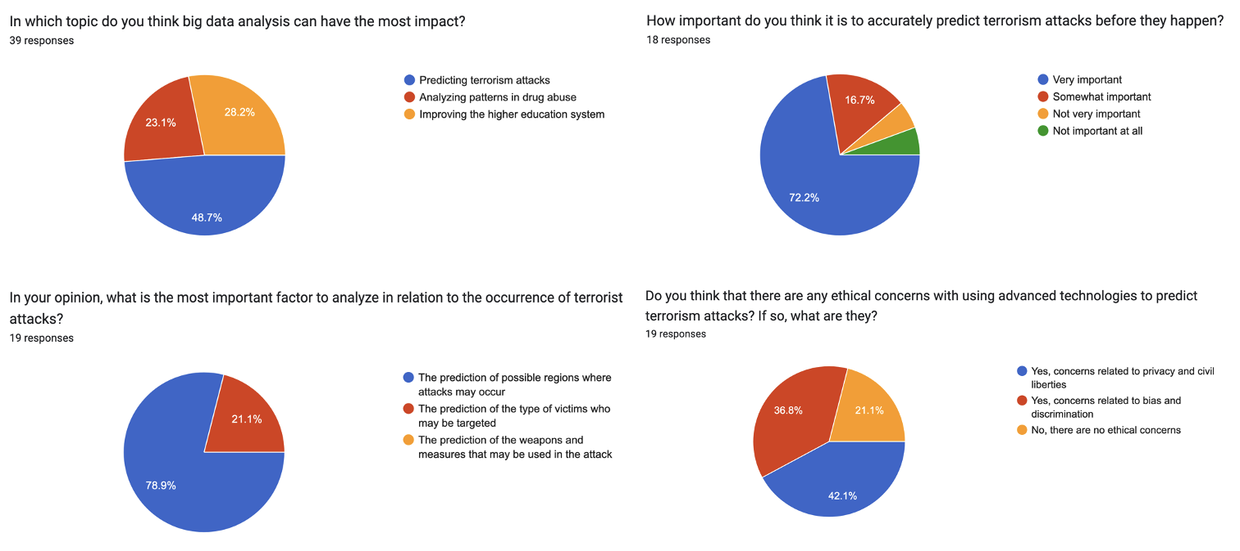

*Figure 1: Survey results of a total of 39 participants*

Based on these results which confirm that terrorism is a topic that concerns a lot of people, we have decided on the following points for the analysis:

* Identifying the main regions of terrorist attacks.
* Patterns regarding the correlation of the location of attack and the weapon used.
* Patterns regarding the correlation of the location of the attack and the type of victim attacked.
* Patterns regarding the correlation of the type of victim and weapon used.
* Patterns regarding the correlation of the location of attack and terrorist (group).
* Patterns regarding the correlation of terrorist (group) and the type of weapon used.
* Identifying any other trends that are not visible to us right now

# Description of data set

Our data set is the Global Terrorism Database (GTD). It is an open-source database which contains information on terrorist attacks from 1970 to June 2021. There are two Excel files. One covers the attacks from 1970 to 2020 and the second one covers the attack in 2021 until June.

The data includes domestic, transnational, and international terrorist attacks containing more than 200.000 cases in total. The dataset's features include information on the date, location, weapons, target as well as when identifiable, the terrorist group behind the attack. There are at least 45 variables for each incident and more than 120 variables for more recent incidents.

To collect the data, more than 4,000,000 news articles from over 25,000 news sources were reviewed.

You can download the data set here: <https://www.start.umd.edu/gtd/contact/download>

# Responsibilities of team members and tools used for analysis

We decided to split the responsibilities as follows:

Everyone is involved in the analysis part. We decided to split the topics:

* **Aliya Huseynova:** Finding patterns in the correlation of victim and weapon as well as location and terrorist group (chapters 5.4 and 5.5 of this report)
* **Tural Alizada:** Finding patterns in the correlation of location and weapon as well as location and victim (chapters 5.2 and 5.3 of this report)
* **Sarah Grothus:** Cleaning the data set, identifying main regions of attack, and finding patterns in the correlation of terrorist groups and weapons (chapters 4, 5.1, and 5.6 of this report)

Everyone wrote their findings and their analysis process in the mentioned chapters. Also, everyone prepared their own slides regarding the findings.

For the analysis, ChatGPT and Python were used. ChatGPT was used to generate prompts regarding the code for the analysis. This code was used in the IDE of the respective team member and adapted if necessary.

# Preparation of data

Link to Jupyter Notebook:

<https://github.com/bda-anaconda/bdateamproject/blob/main/cleaning_data.ipynb>

The data was already well curated, but there were some columns that are not relevant for our analysis purposes and the data set consisted of two different excel sheets. The first excel sheet described terrorist attacks from 1970 to 2020 and the second from January to June 2021.

To make the analysis simpler, we decided to first of all delete all the columns that are not necessary for our analysis. For this, we used Python (Jupyter Notebook), the IDE Visual Studio Code as well as ChatGPT for guidance.

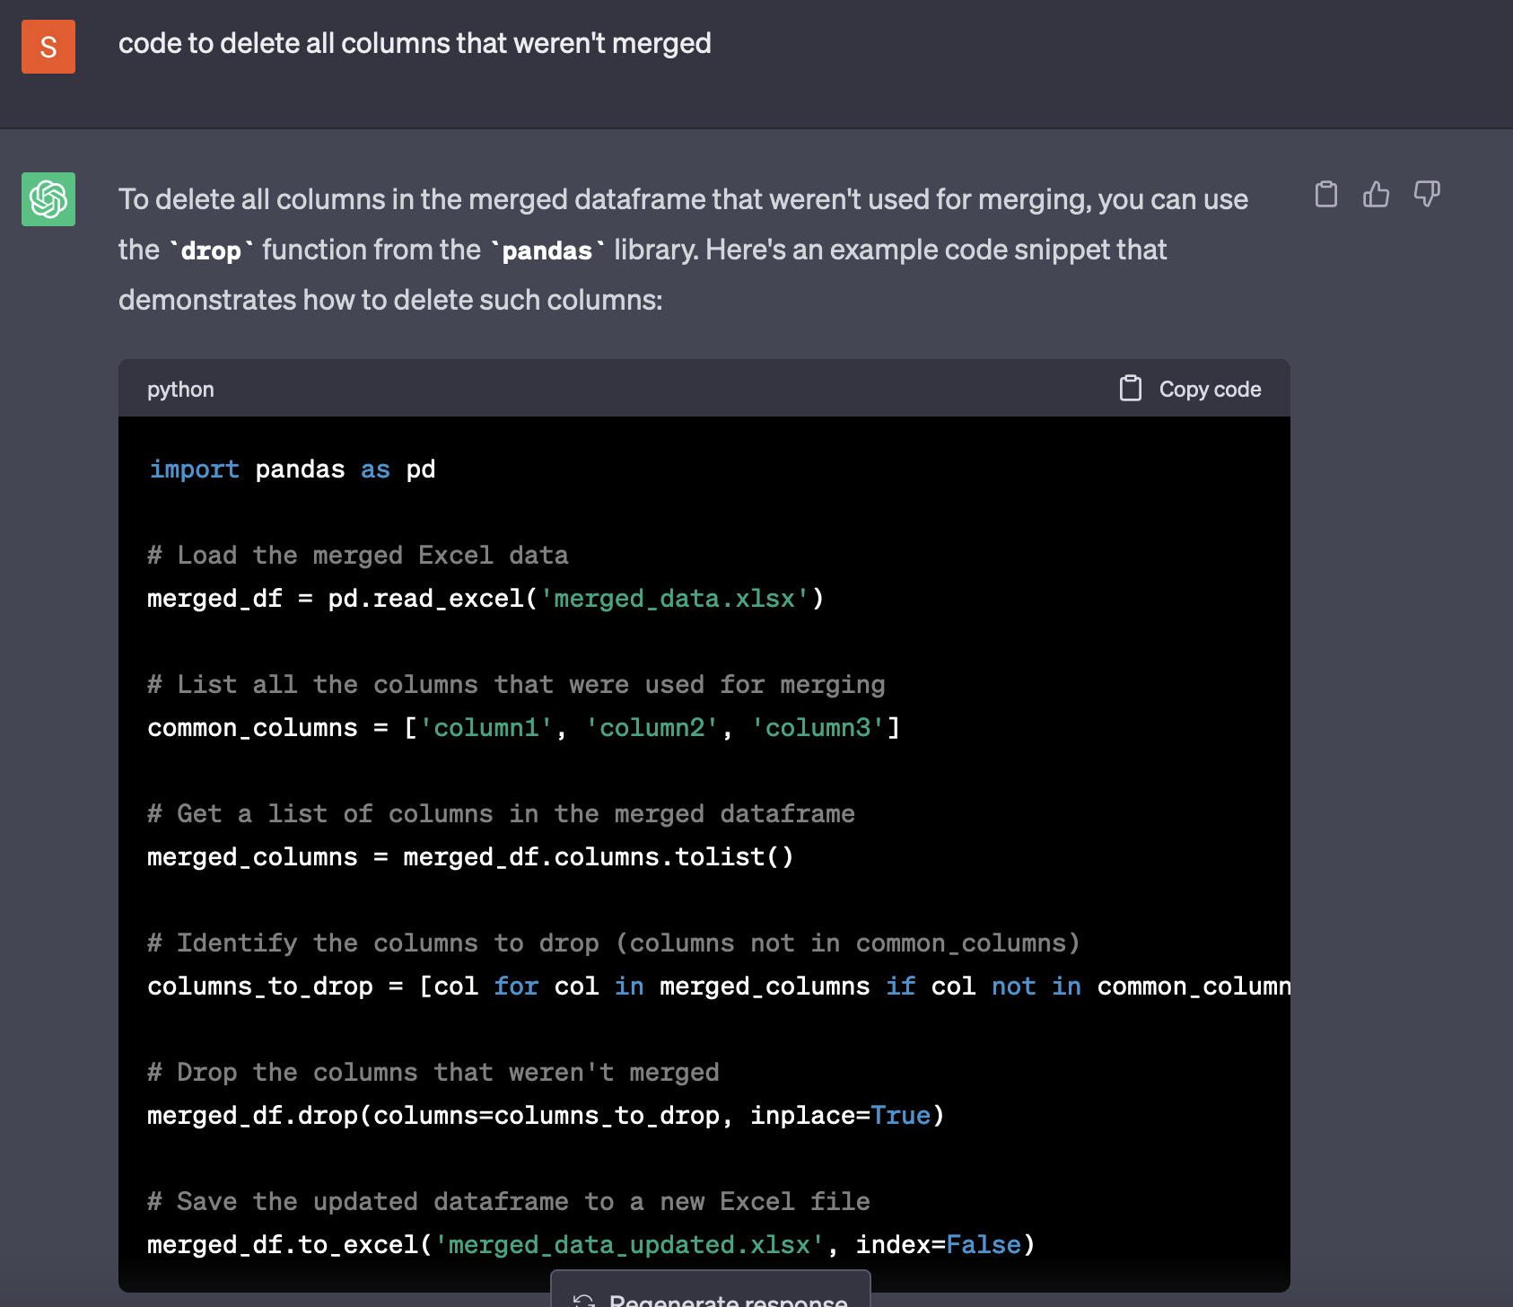

*Figure 2: ChatGPT prompt to receive guidance regarding deleting columns*

The first approach was to first merge the two excel sheets, but it turned out that it took too much time due to the size of the file. So, we deleted the unnecessary columns first to reduce the size with this Python code:



*Figure 3: Import pandas*

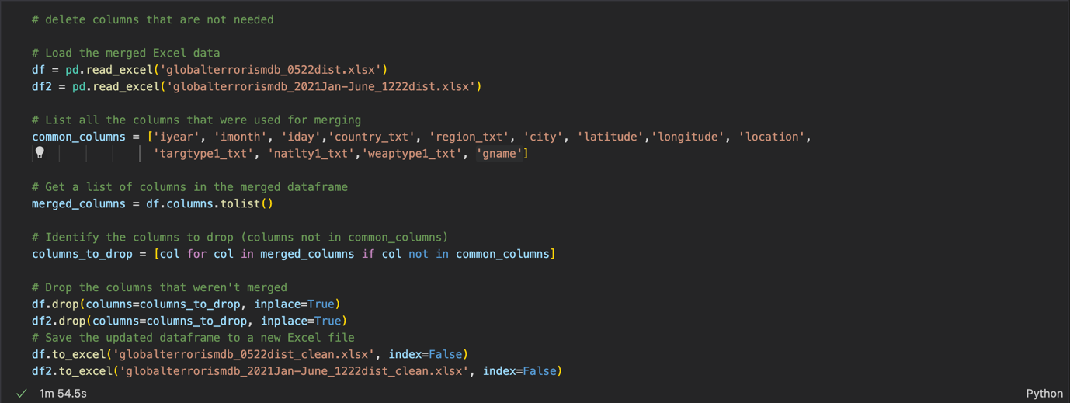

*Figure 4 Python code to delete columns that are not needed*

First, both excel sheets were saved into the variables df and df2. Then, the columns that we want to keep were defined. Based on our analysis focus, we decided to keep year, month, day, country, region, city, latitude, longitude, location, target type, nationality of victim, weapon type as well as the name of the terrorist group. Then all the needed columns are transformed into a list and all columns whose names are not in the list are dropped. Then, both excel sheets were saved.

In a next step, the two excel sheets were merged in order to just have one sheet with all necessary information:

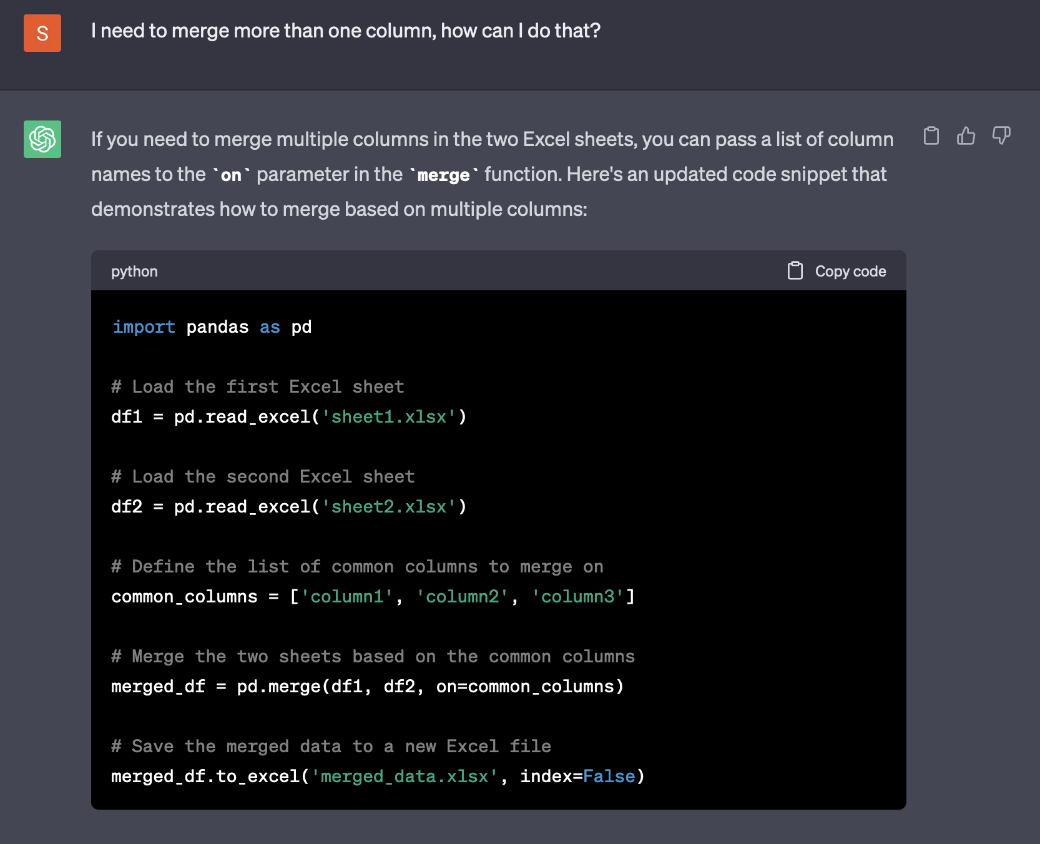

*Figure 5: ChatGPT prompt for merging*

The answer was changed into following python code:

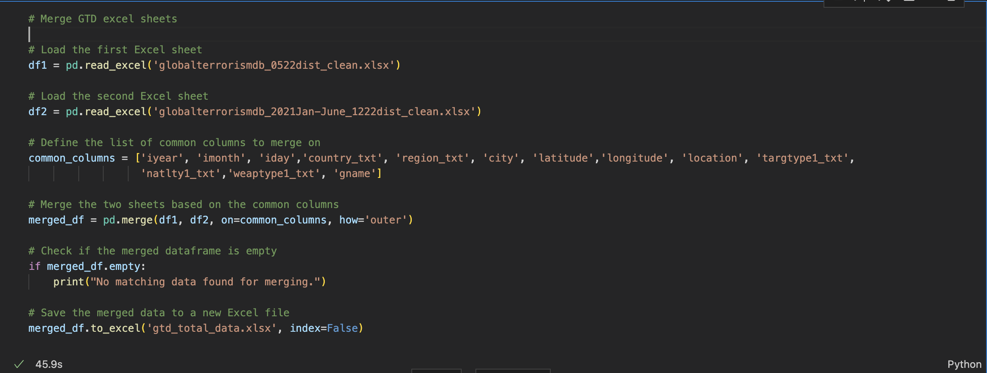

*Figure 6: Python code for merging*

Both previously cleaned excel sheets were selected and the columns that should be merged which are all the columns that we kept, were defined. Then, a full outer join was performed, adding the rows from both sheets into the defined columns of just one sheet.

In order to make the analysis in the following steps easier, a column with the date in datetime format was added:

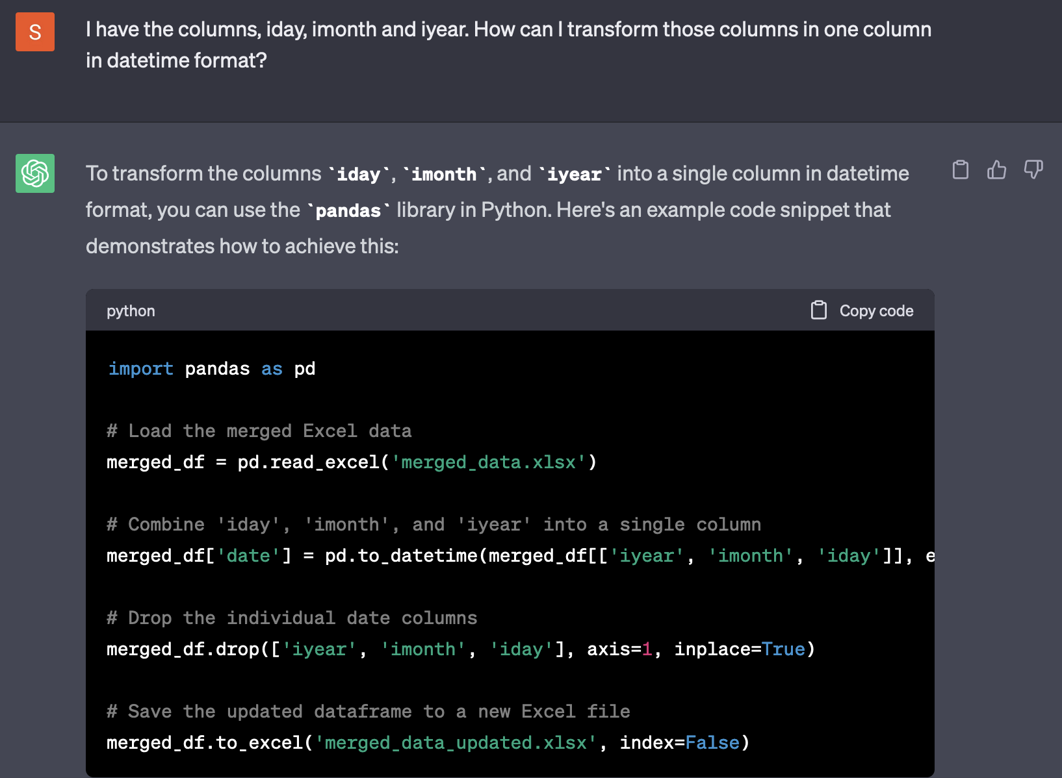

*Figure 7: Prompt to add column date containing datetime object*

We decided to keep the day, month and year columns and just add the date column:

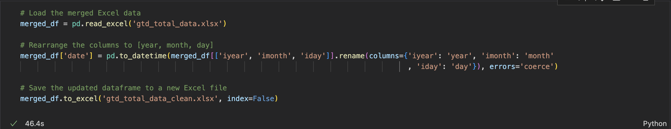

*Figure 8: Python code to add column date containing datetime object*

The column date is added by changing the order of the columns into datetime format (year, month, day) and then transforming the information into a datetime object. The final excel sheet looks like this:

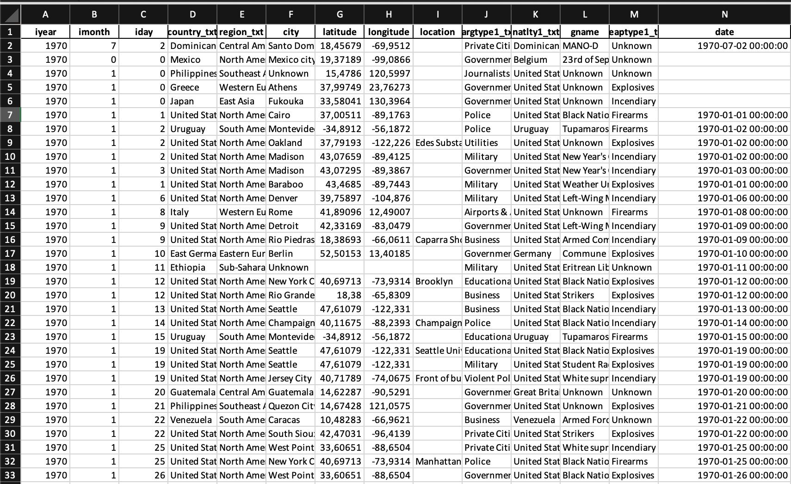

*Figure 9: Cleaned excel sheet*

We now have one excel sheet that contains all the features we want to analyze (15 columns).

# Performing the analysis and describing the results

## Main regions of terrorist attacks

Link to Jupyter Notebook: <https://github.com/bda-anaconda/bdateamproject/blob/main/main_regions_of_attack.ipynb>

First, the idea was to plot all of the historic attack data on a world map to identify the regions where terrorist attacks occur most often:

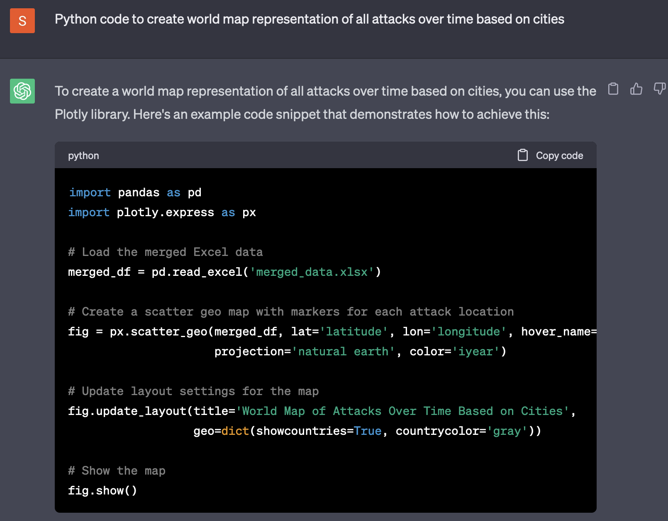

*Figure 10: ChatGPT prompt to plot attacks on map*

This led to following python code:

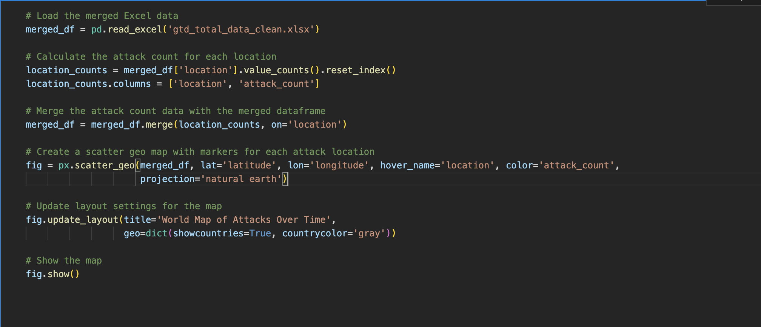

*Figure 11: Python code for plotting all attacks*

With the python code, the number of attacks for each region was counted using the longitude and latitude columns. This allows for an exact plotting on the map. Also, the feature that you can see a more detailed location description, was added. Then, using plotly and its scatter_geo function, the points were projected on the map:

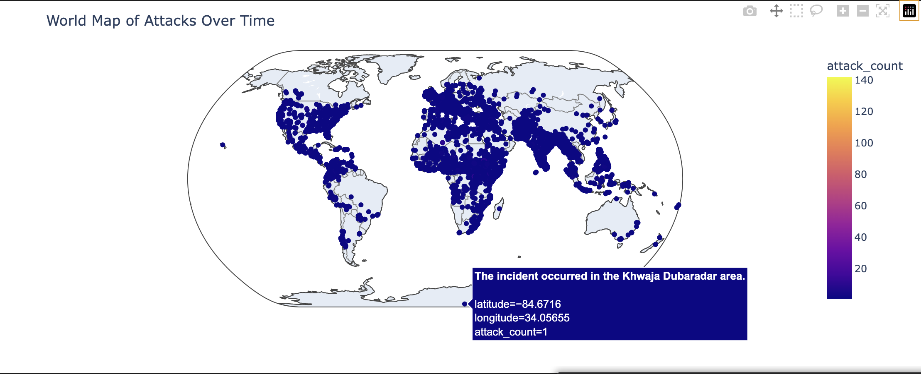

*Figure 12: World map with all terrorist attacks*

The map allows for a first impression of hot spots. You can for example say that in countries like Australia, Canada and Russia it did not occur very often. However, since there is no real clustering, some countries are completely filled with dots which makes it hard to find the exact hot spots. Also, taking data from the last 50 years means that your impression might be fooled by outdated data since it is possible that some countries were affected very heavily in the 1970s but nowadays not that much.

That is why an interactive heat map was created, which allows you to zoom in and see the affected areas in every country. For that, the attacks from the last 15 years were considered:

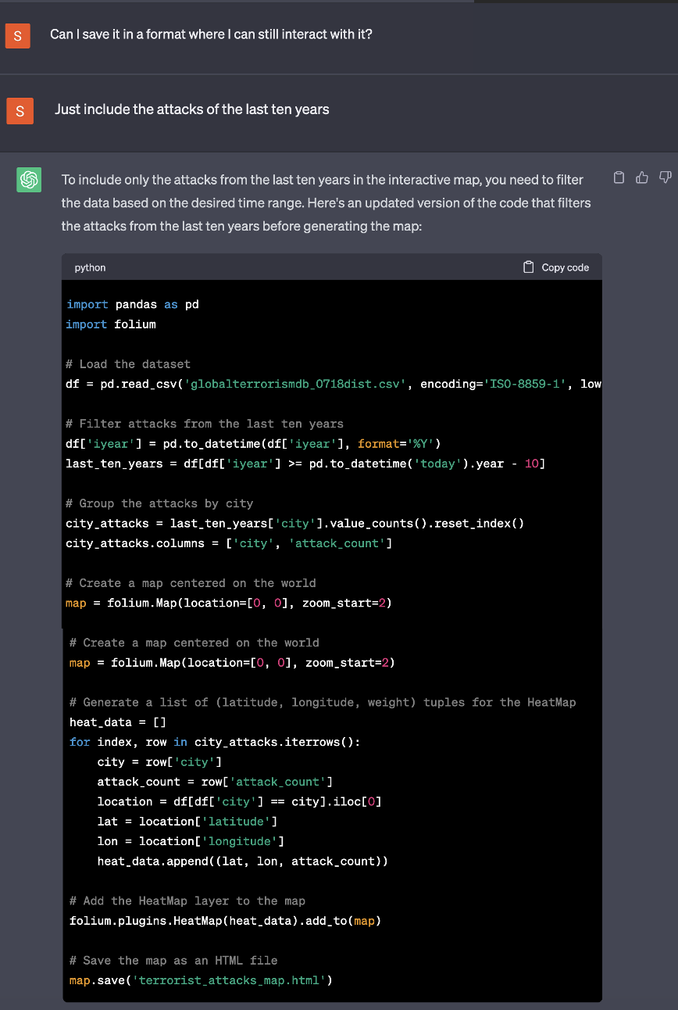

*Figure 13: Prompt that ended in code for heat map*

Interestingly enough, there was not prompt that specifically asked for a heat map, the idea came from ChatGPT. The prompt and code from ChatGPT is for the last 10 years, but we decided to include the last 15 and just made these changes in the code:

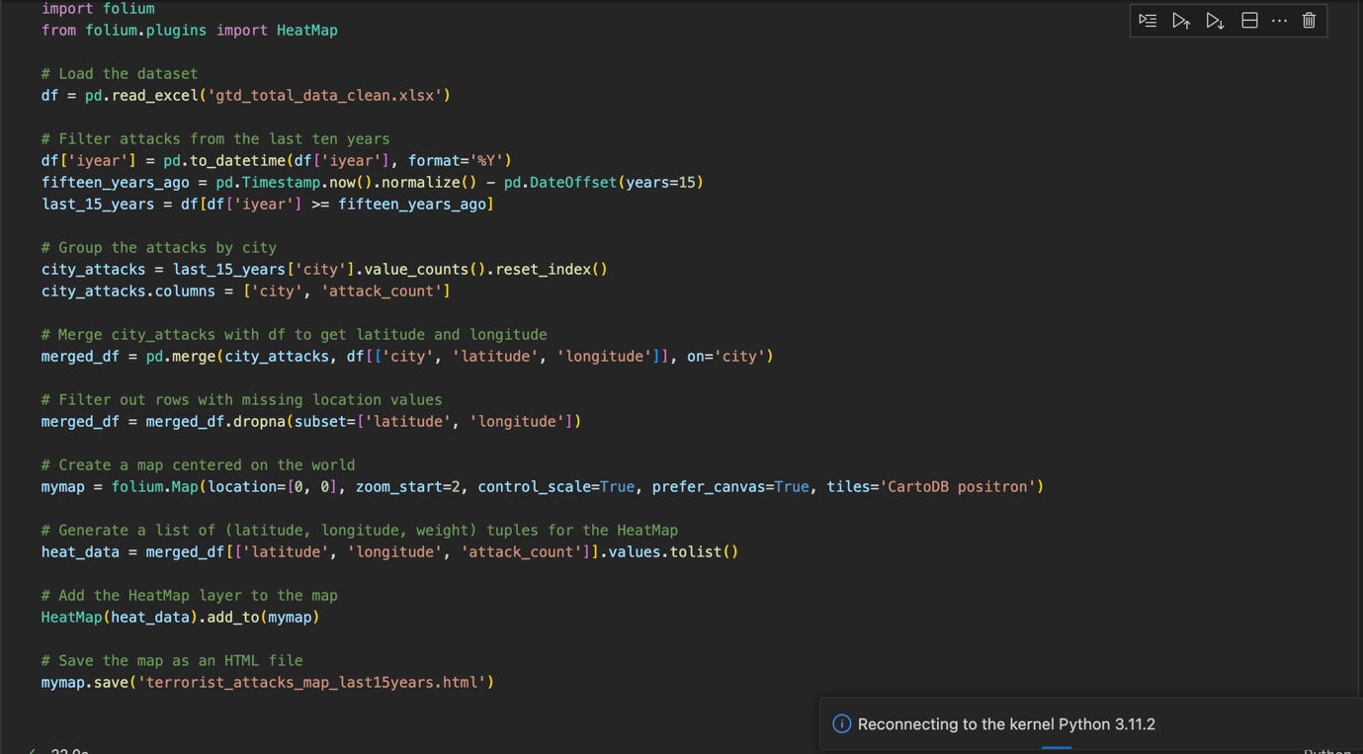

*Figure 14: Python code for heat map*

After loading the data set, the year is transformed into the datetime format to only select attacks from the last 15 years based on today’s timestamp (19.05.2023). There already was a column containing the datetime format, so this step was not necessary, but the prompt given did not include that information. The attacks were grouped by city and then rows with missing values were dropped. Then, using folium, the map was created and using the heat_map functionality, the layer was added on top. Then the file was saved (“terrorist_attacks_map_last15years.html). You can find the html file here on our GitHub account:

<https://github.com/bda-anaconda/bdateamproject/commit/8e1dd6e2e4770802758215d299244b0c9287b6a7>.

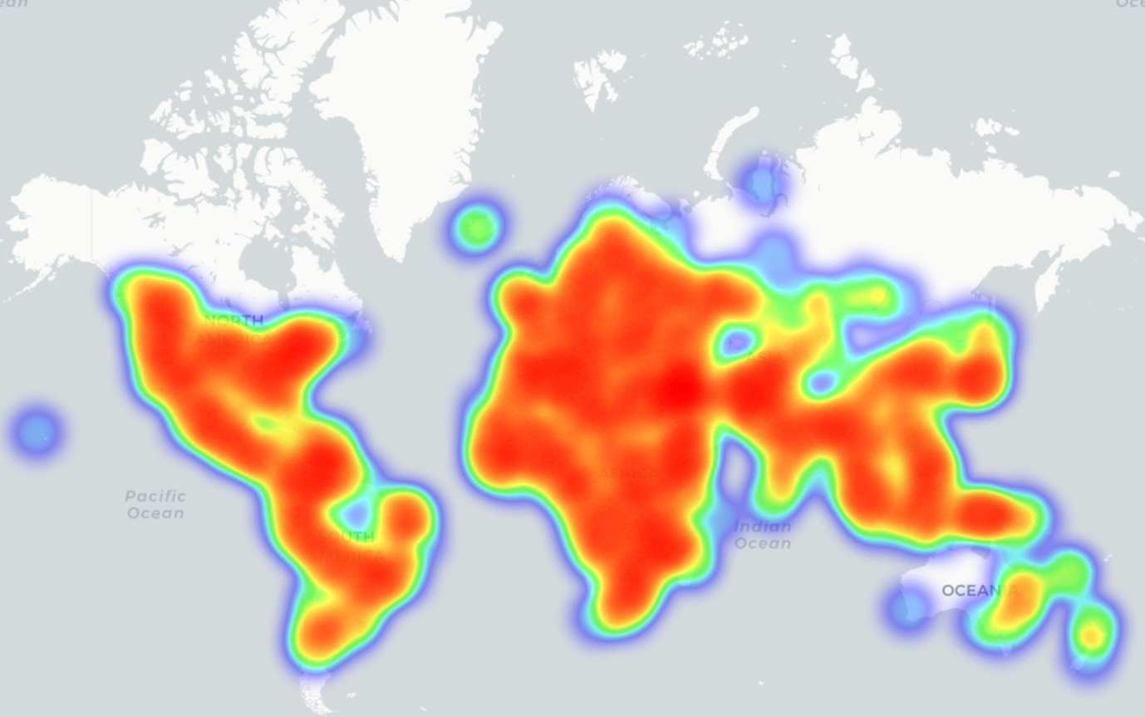

*Figure 15: Heat map of attacks from the last 15 years*

On the first sight, it does not seem more useful than the previous map. But the function to scroll in as well as the colors allow for a deeper analysis of the locations.

Let us take the United States as an example:

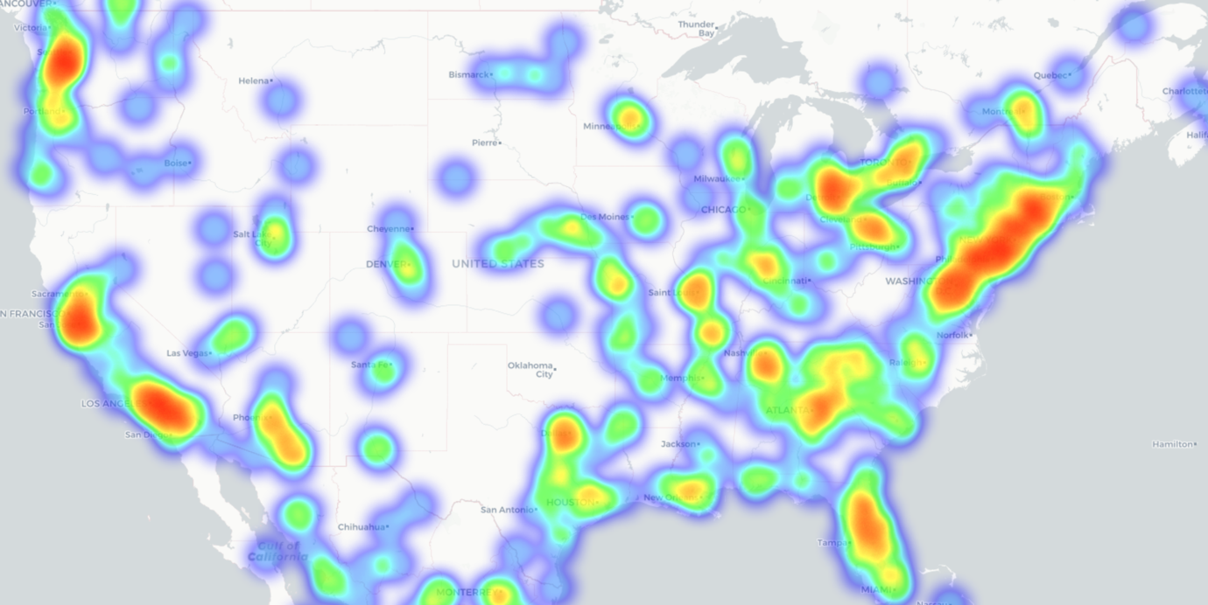

*Figure 16: Heat map terrorist attacks from last 15 years USA*

The map clearly shows the most affected regions. It is apparent that the east coast was especially affected by terrorist attacks. The west coast also faced several attacks whereas there are only isolated attacks in the middle west region. You can also see that attacks mainly centered around big cities like New York City, Washington D.C., Jacksonville, Orlando, Atlanta, Los Angeles, Milwaukee, Boston, as well as San José.

As a next step, the countries that are most affected by terrorist attacks were identified numerically:

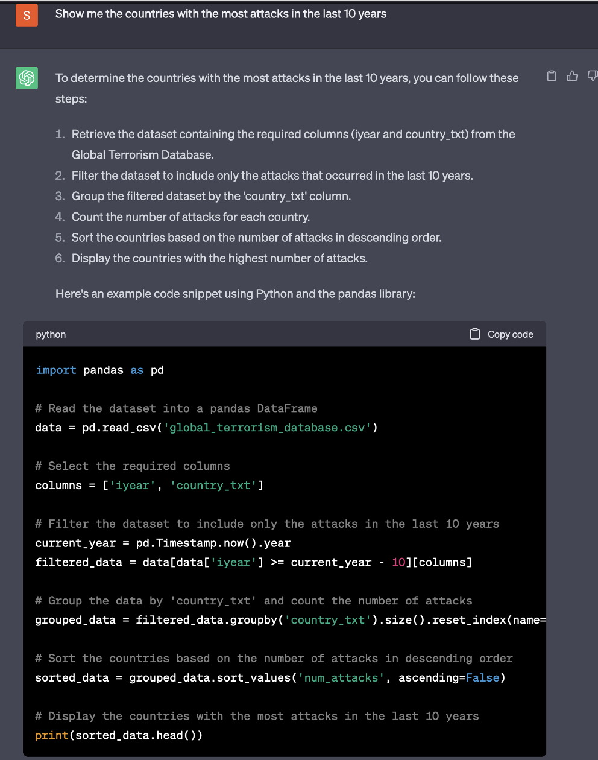

*Figure 17: Prompt to list countries most affected by terrorism in the past 10 years*

Here again, it was decided to change it from past 10 to past 15 years:

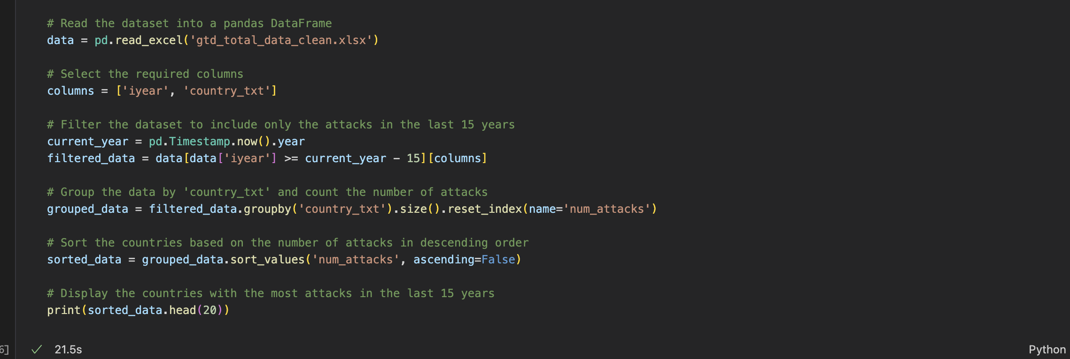

*Figure 18: Code to list countries most affected by terrorism in the past 15 years*

Using the groupby function, the attacks per country are counted and then sorted in descending order using the sort_values function. Then the 20 most affected countries were displayed:

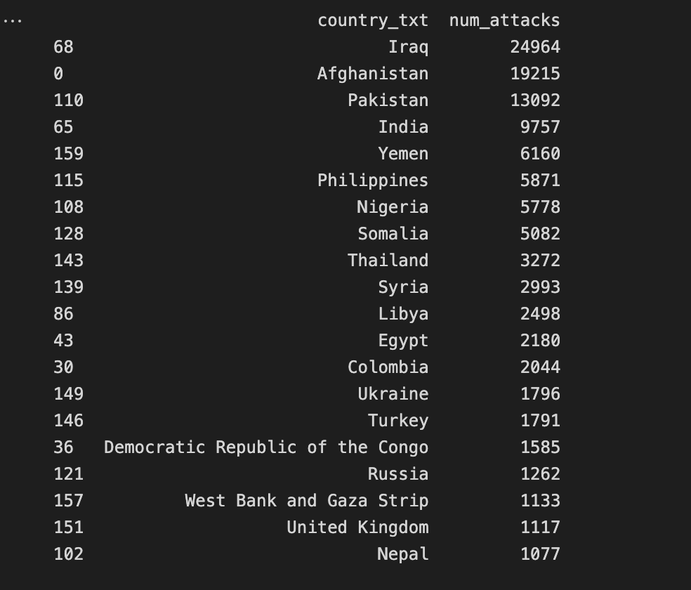

*Figure 19: 20 most affected countries by terrorism in past 15 years*

To look closer at the situation in Iraq, you can use the previously created heat map:

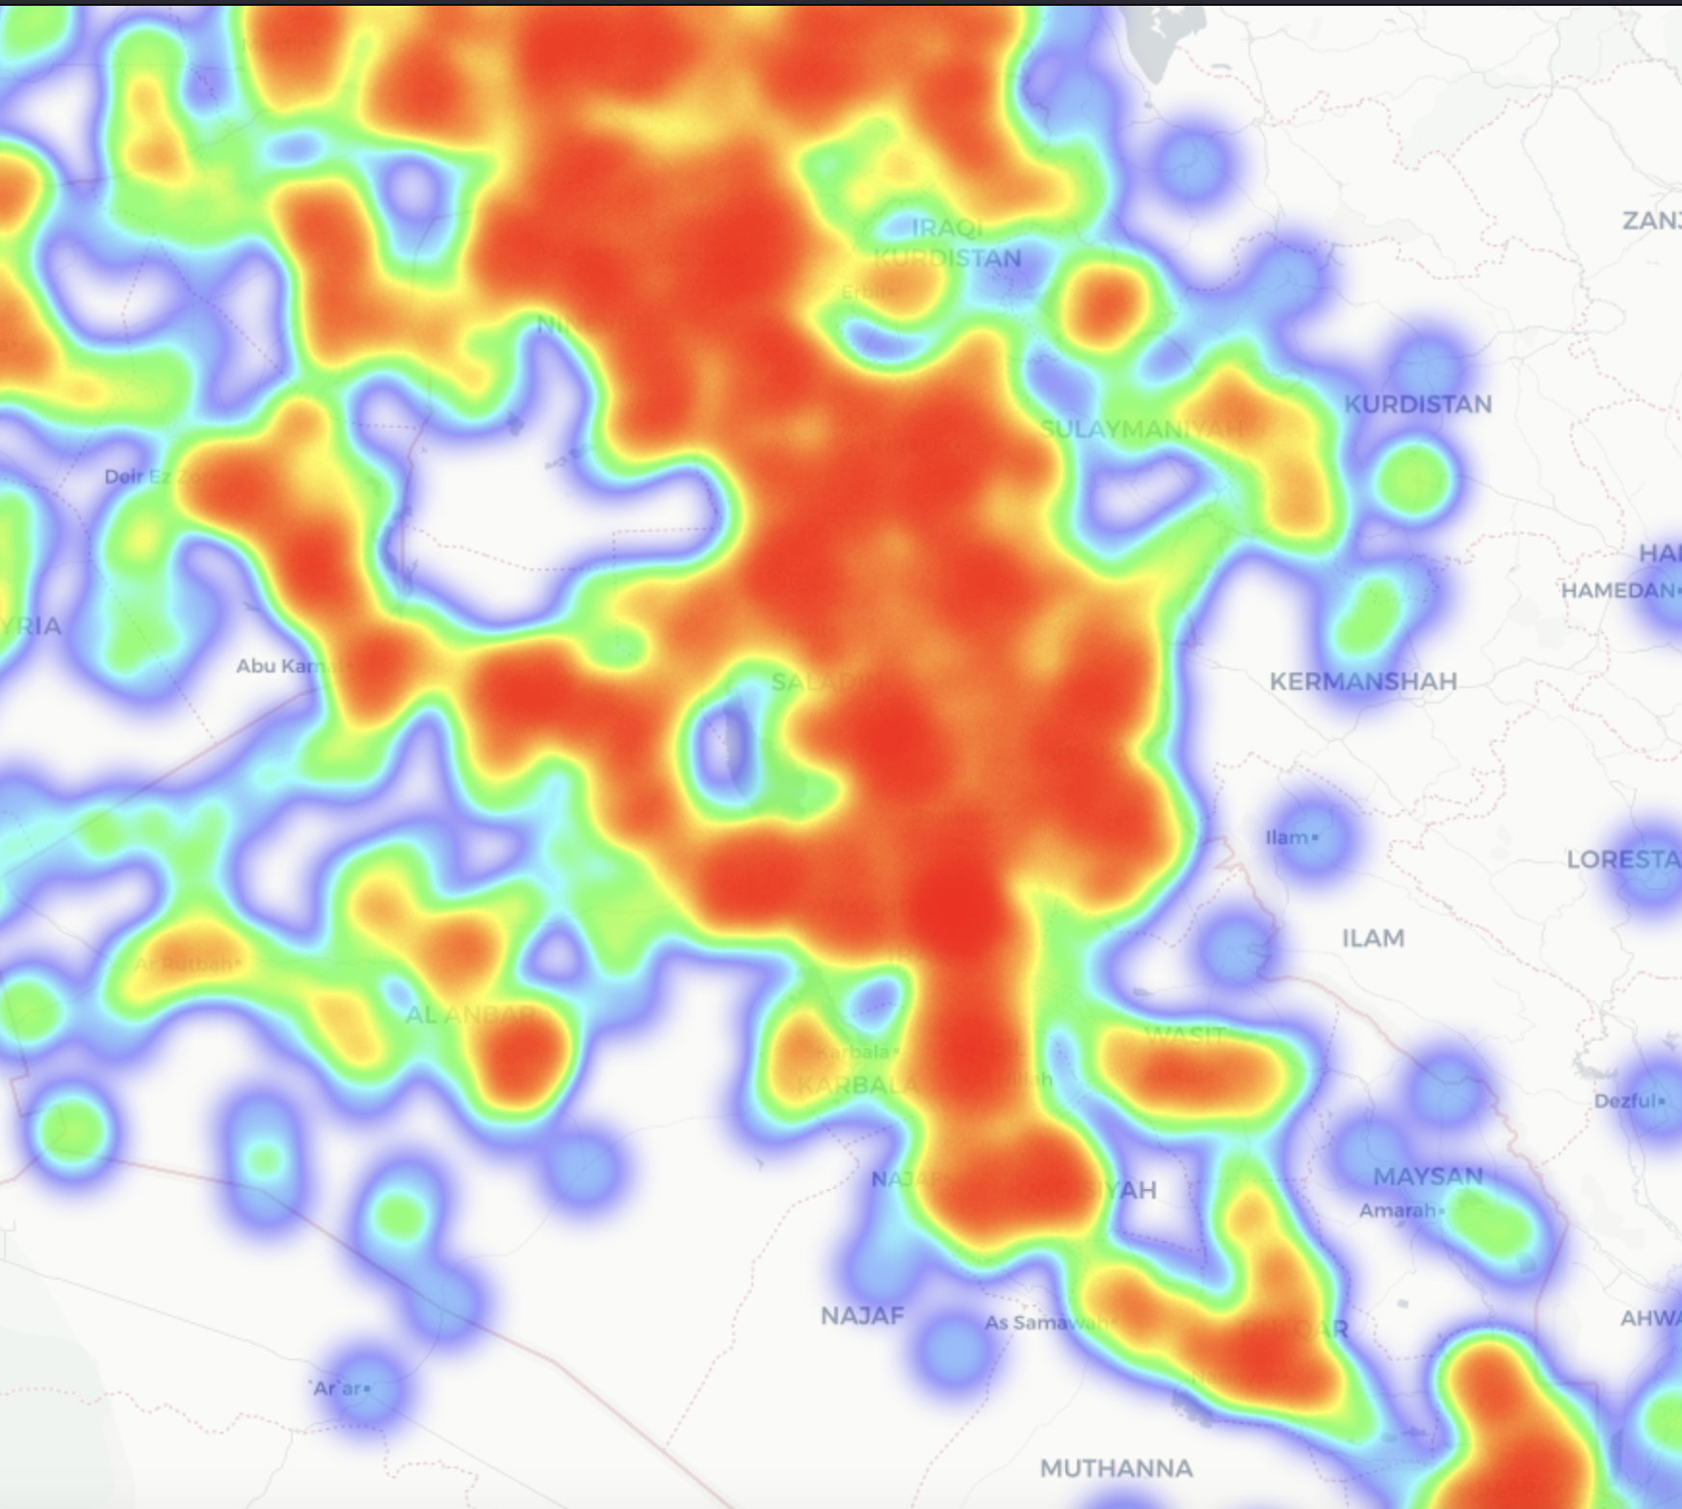

*Figure 20: Terrorist attacks in Iraq in last 15 years*

The map shows that most of Iraq is affected, but also that regarding terrorism, the western and southern regions are much safer than the eastern and northern regions.

Surprisingly enough, one country that is usually considered quite safe appears in the list which is the United Kingdom:

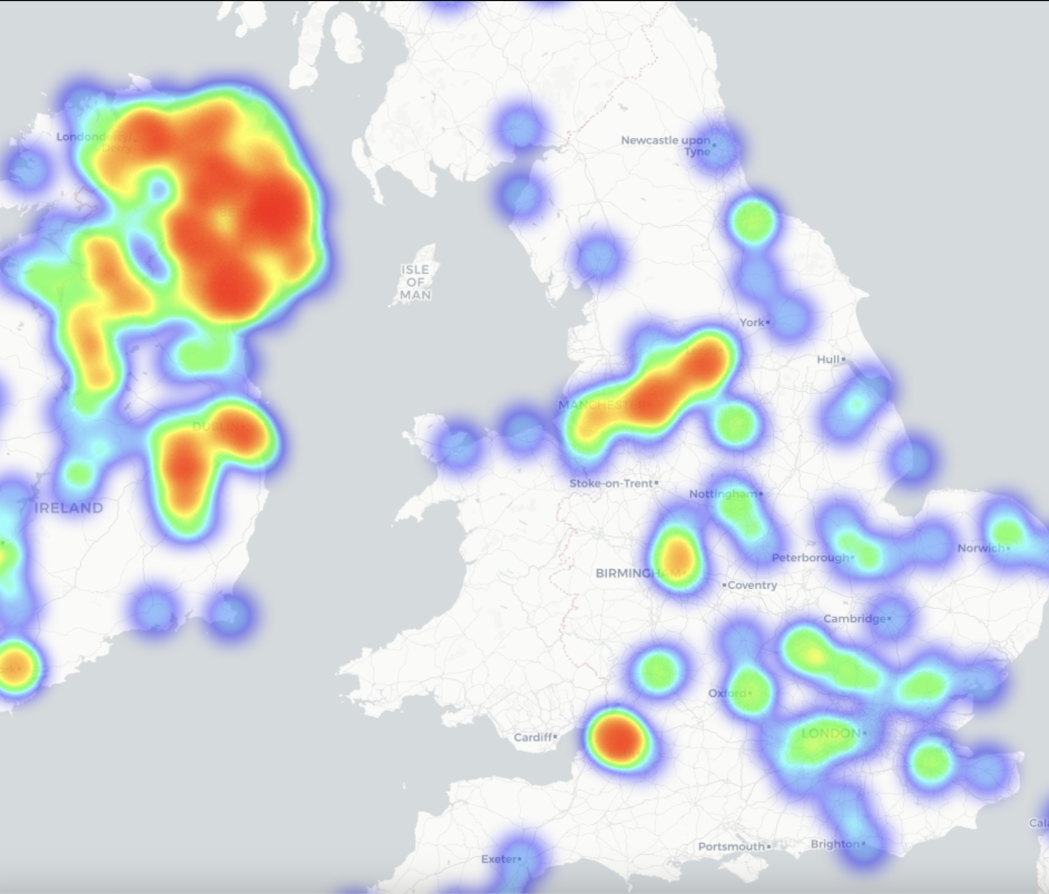

*Figure 21: Terrorist attacks in the UK in the last 15 years*

When looking at the map, it is apparent that it is mainly Northern Ireland that is affected, probably because of the historical conflict with the Republic of Ireland. This can serve as an indication that it might be good to think about improving security measures in Northern Ireland.

## Correlation of location of attack and weapon used

At first, tried to find top 10 most common locations of attack and the corresponding weapons used in the cities: Here is the code, and result:

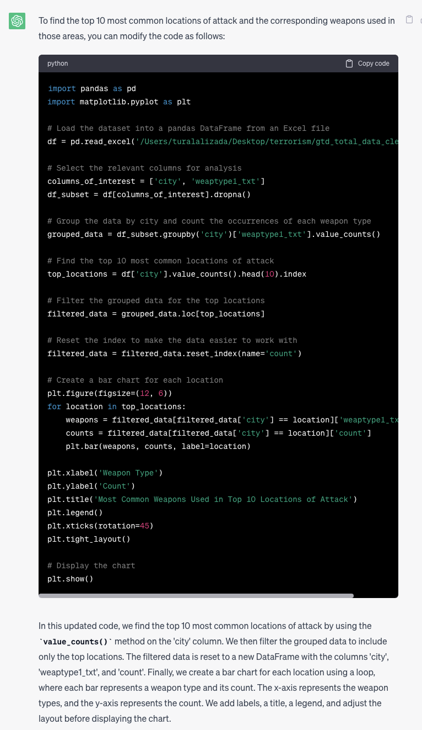

*Output(Result):*

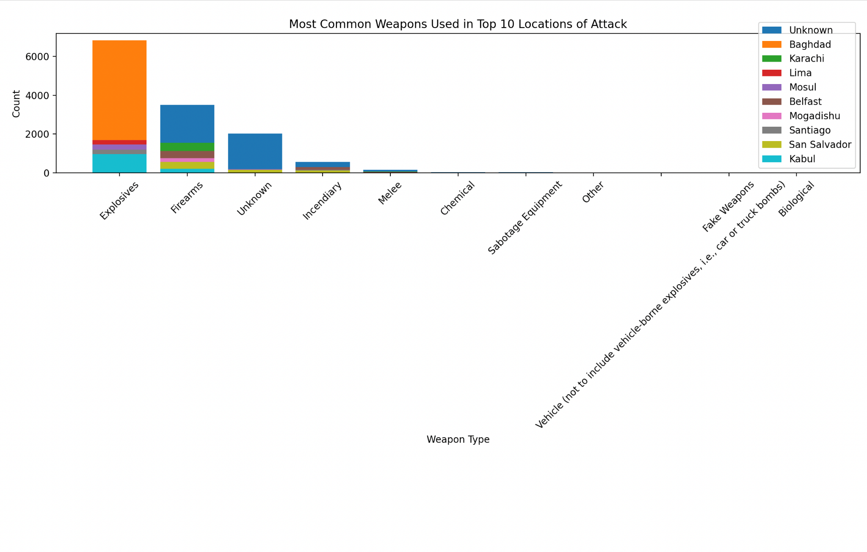

As you can see, we have a result, but the exact number is not showing. For showing this, that is the exact code:

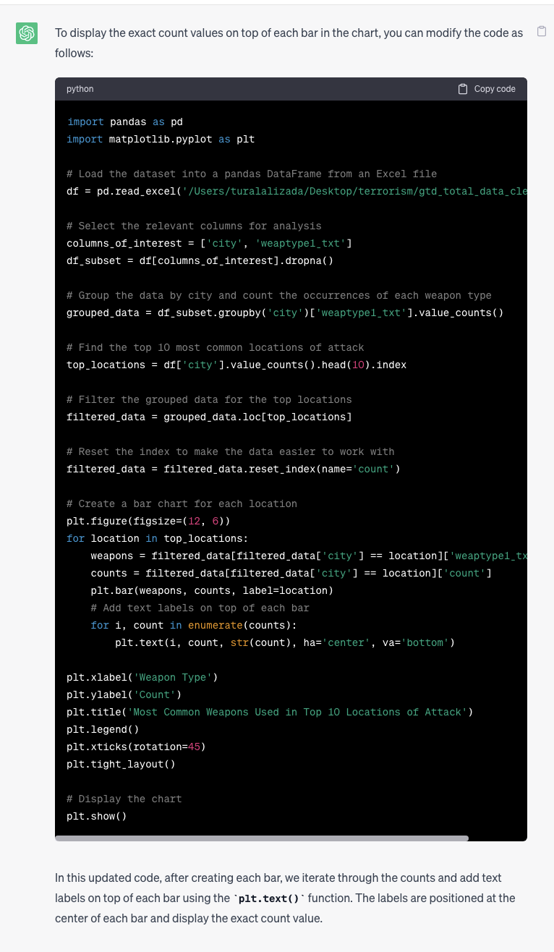

Output(Result):

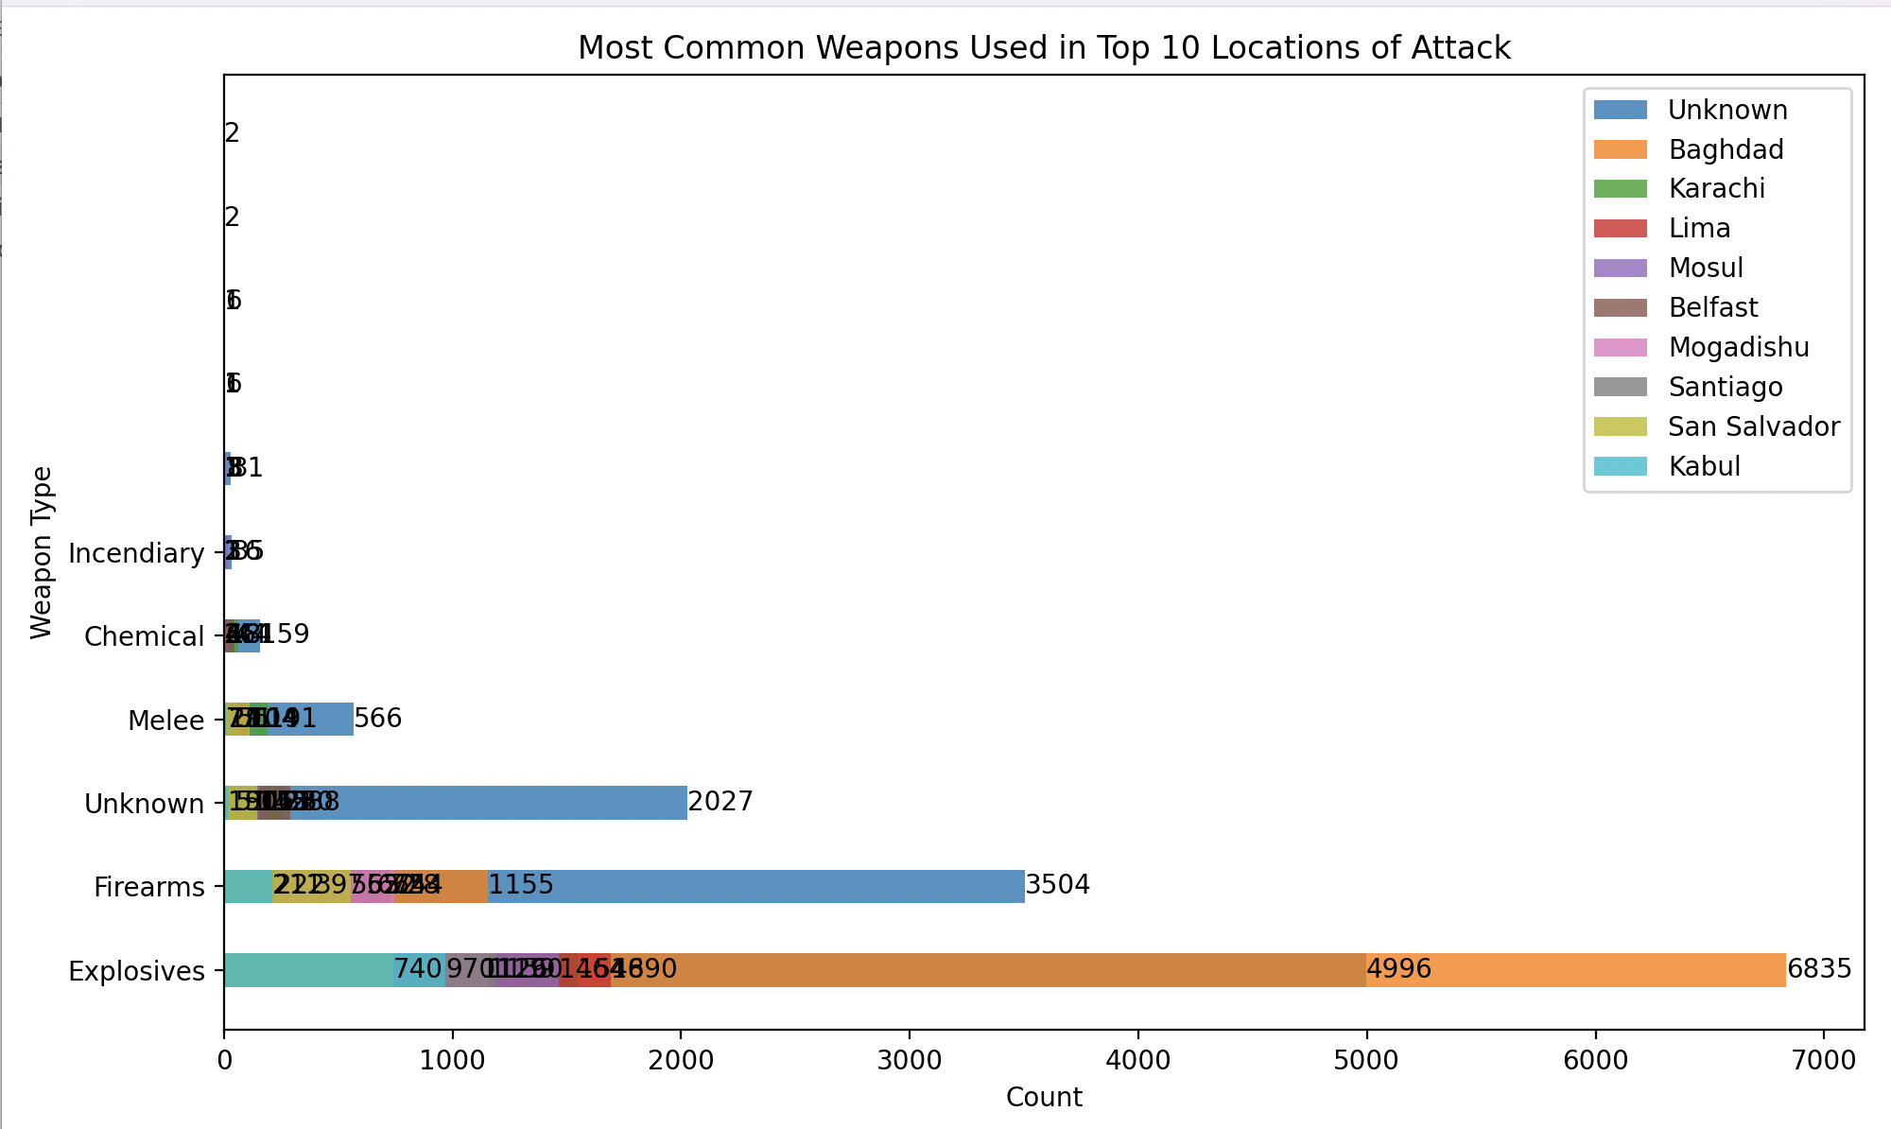

## Correlation of location of attack and type of victim attacked

At first, I tried to take Python code from Chat-GPT and asked about the most common areas for each type of victim. The code described below is giving the result:

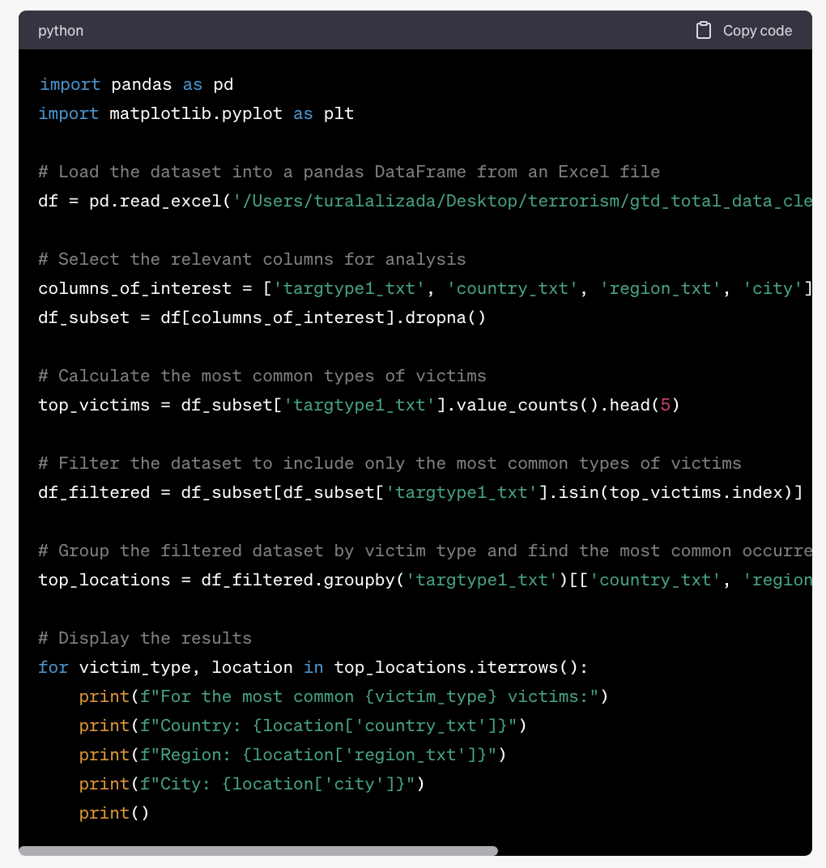

***Output:***

For the most common Business victims:

Country: Iraq

Region: Middle East & North Africa

City: Baghdad

For the most common Government (General) victims:

Country: Afghanistan

Region: South Asia

City: Unknown

For the most common Military victims:

Country: Afghanistan

Region: Middle East & North Africa

City: Unknown

For the most common Police victims:

Country: Afghanistan

Region: South Asia

City: Unknown

For the most common Private Citizens & Property victims:

Country: Iraq

Region: Middle East & North Africa

City: Baghdad

*Then, asked Chat-GPT to create a chart based on that info: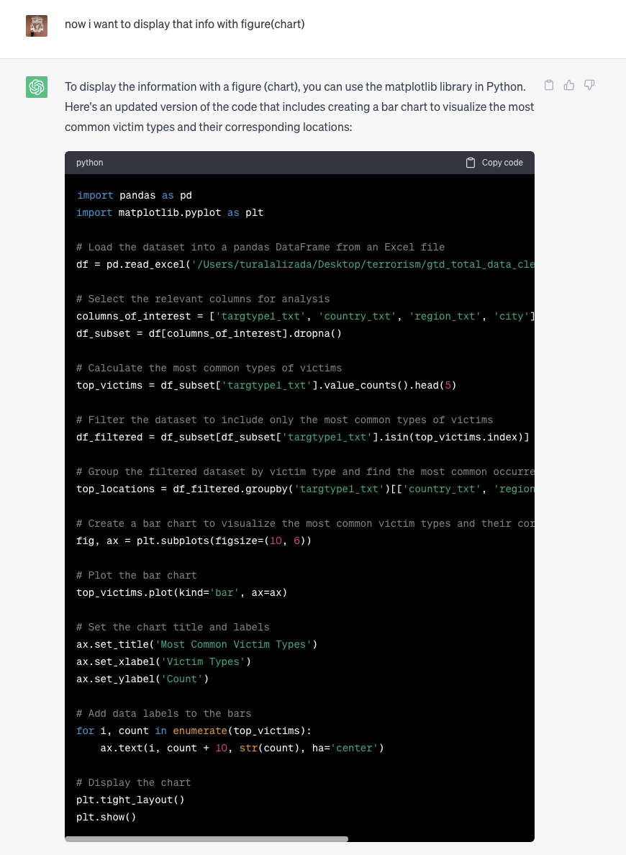*

*Output(Result):*

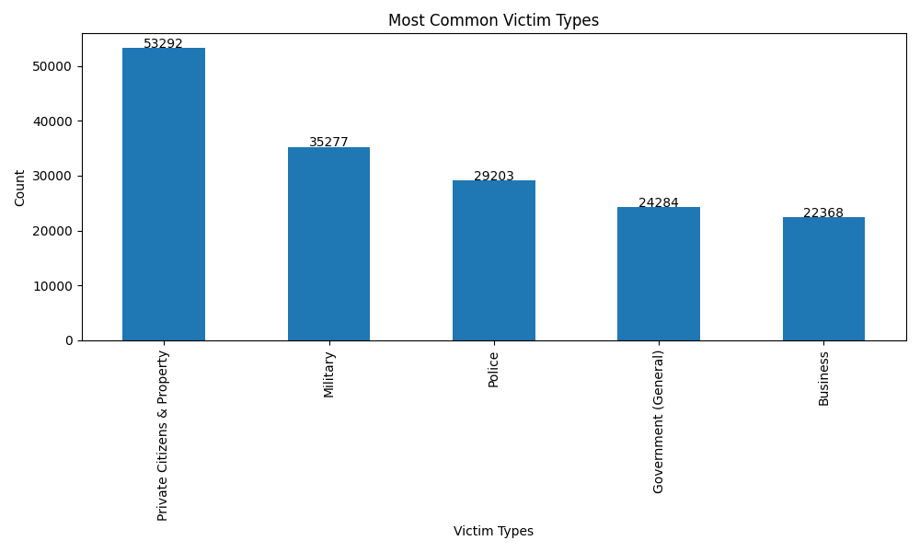

After that, to show the more detailed information about correlation of location of attack and type of attacked, I asked Chat-GPT to add city name into the chart:

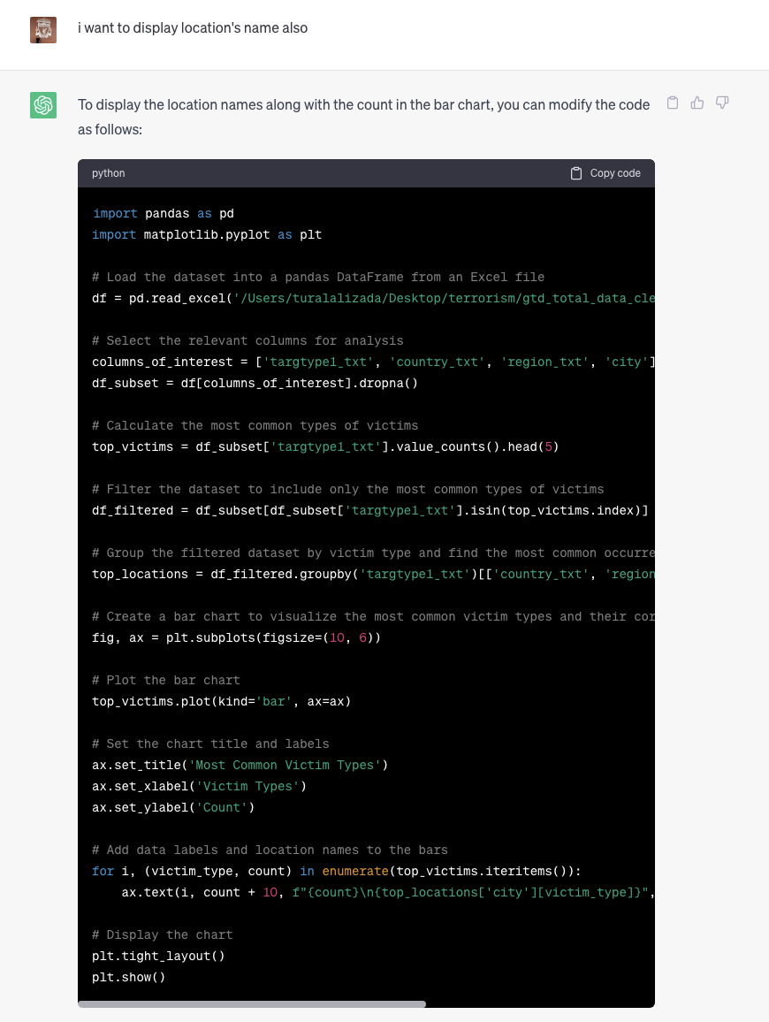

*Output(Result):*

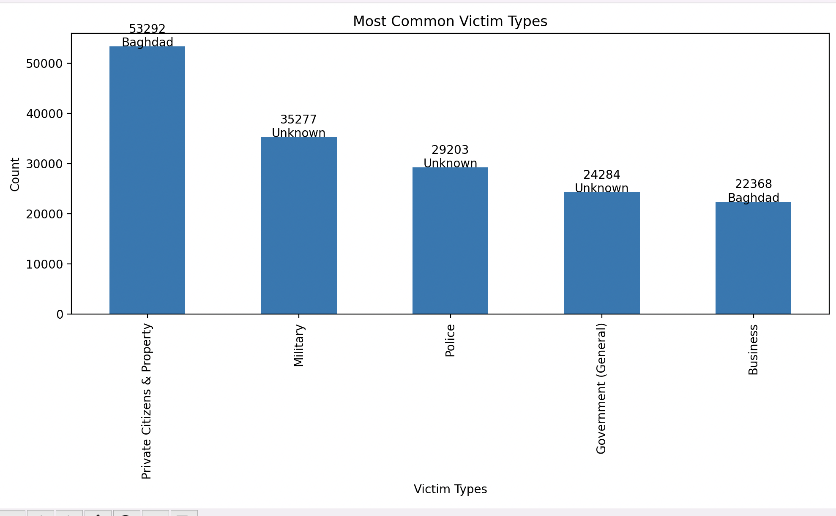

## Correlation of type of victim and weapon used

Firstly, AI language model proceeds the input of “I have a Global Terrorism Dataset, with the columns of iyear, imonth, iday, country_txt, region_txt, city, latitude, longitude, attacktype1_txt, targtype1_txt, targsubtype1_txt, corp1, target1, natlty1_txt, gname, weaptype1_txt. Are there patterns of correlation between type of victim and used weapons?” and presents the next code:

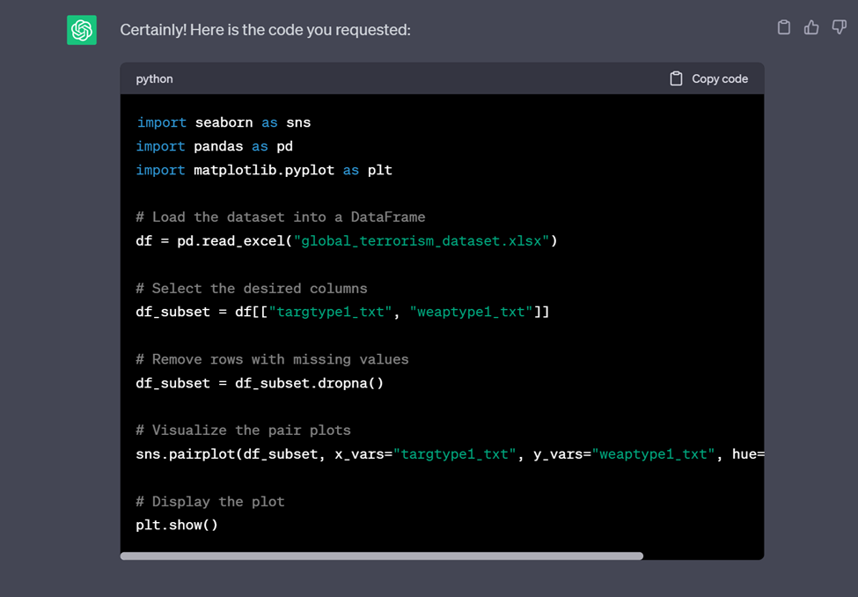

As it can be observed, sns.pairplot is used in this code: it represents a grid of scatter plots, where each point shows correlation between variables. The code already eliminated unnecessary columns, which might cause pollution in final output, and focused only on two columns, “targtype1_txt” and “weaptype1_txt”. As a result, when executing this code in the PyCharm environment, the next result is obtained:

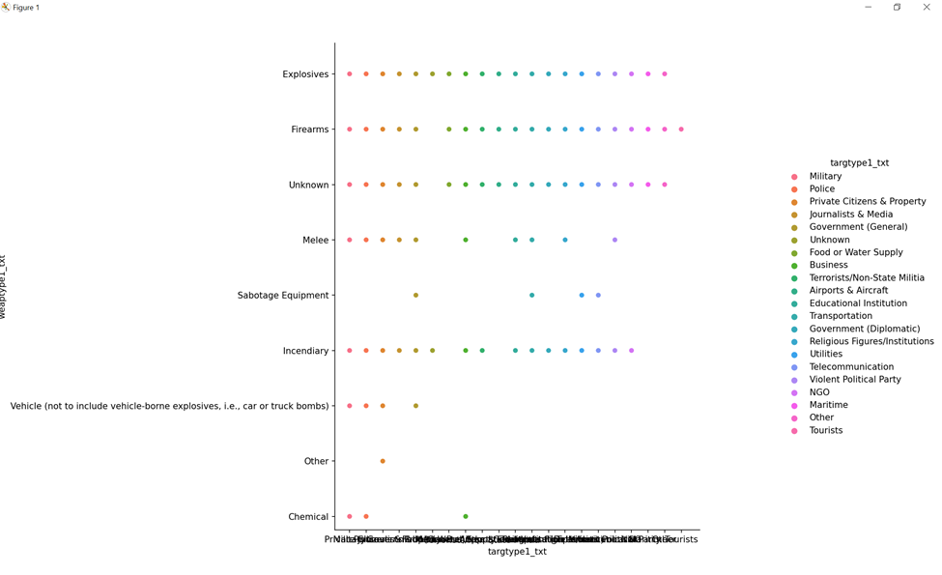

This figure shows the correlation between type of victims and used weapons.

In order to make the results more precise, the next prompt is getting examined:

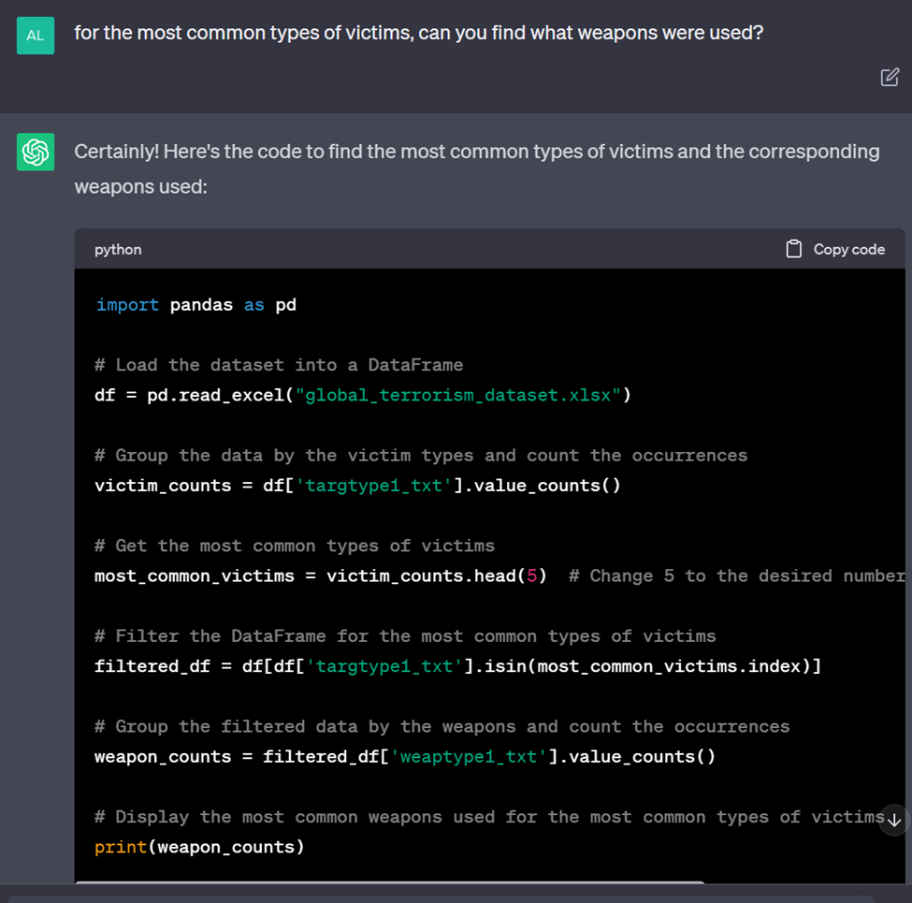

After running this code in PyCharm environment, the following output is received:

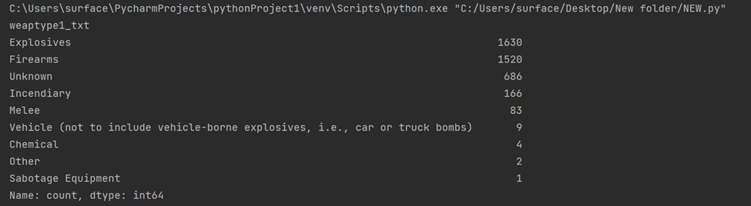

In order to get clearer understanding with precise visualization, the new code is requested:

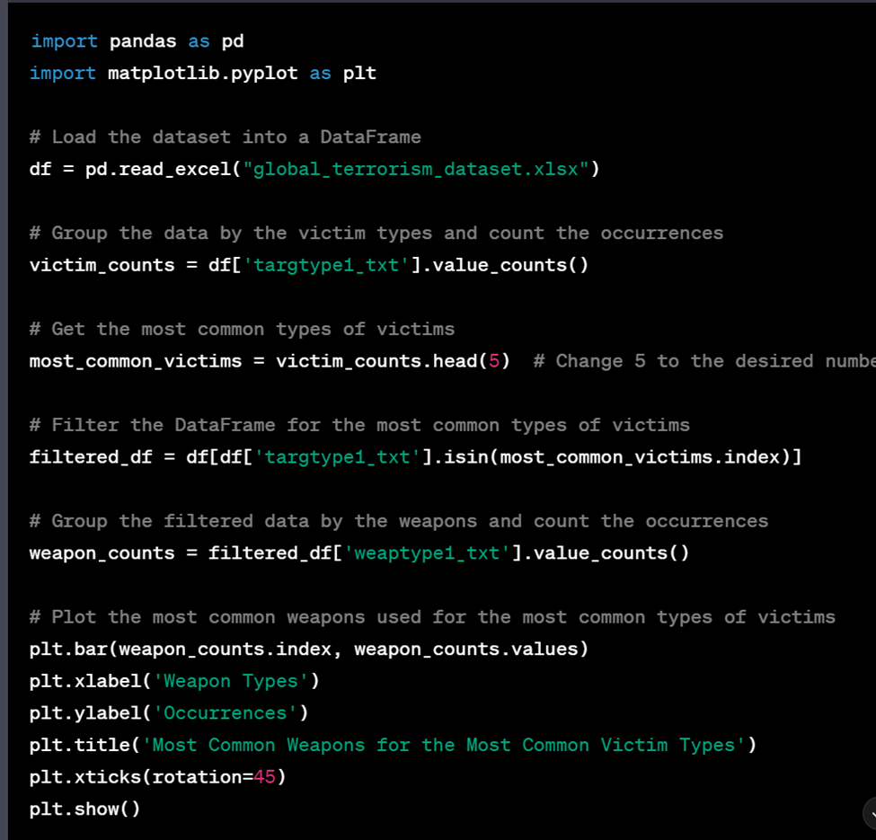

The output consists of the next graph:

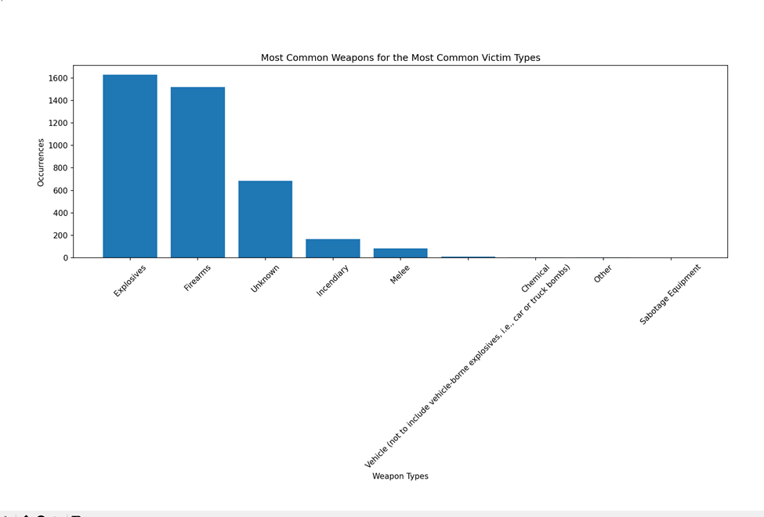

According to the graph, it can be observed what is the number of occurrences for each type of weapon - from the most common one to the least common one, in ascending order.

To get clearer visualization of correlation between the variables, there is a request:

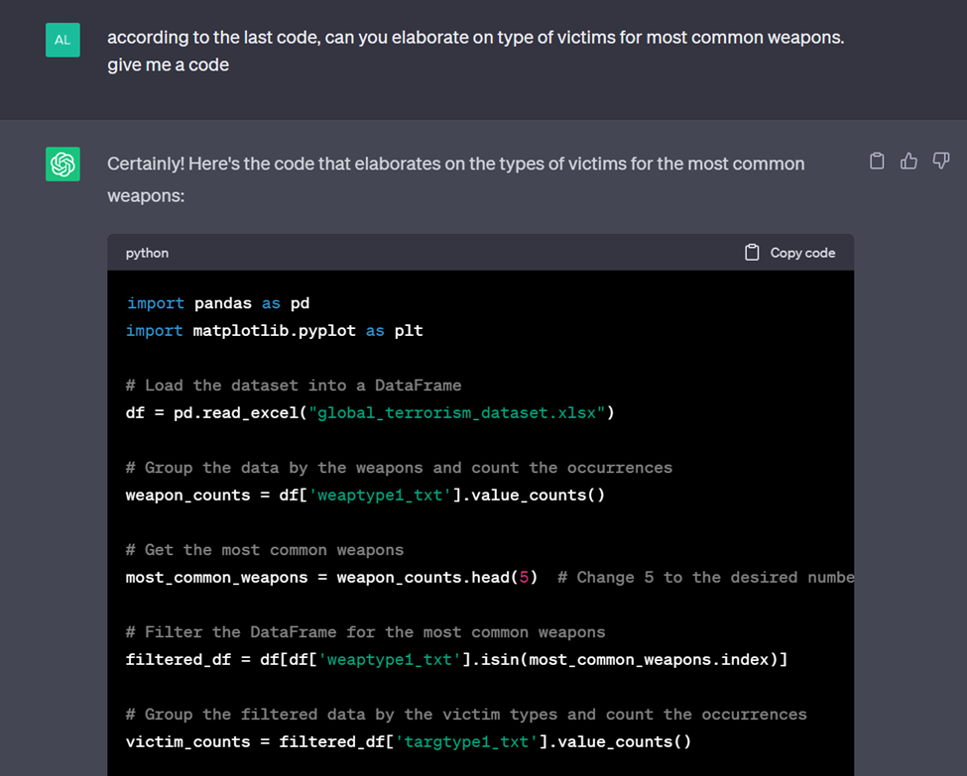

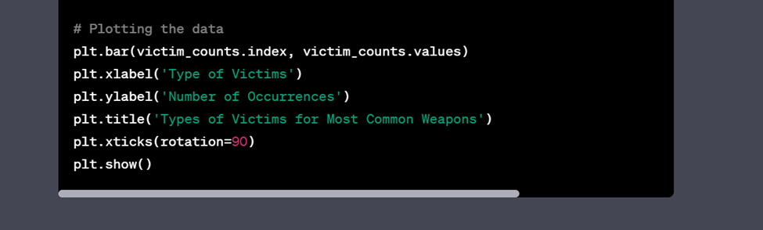

After running the code, the next results are obtained:

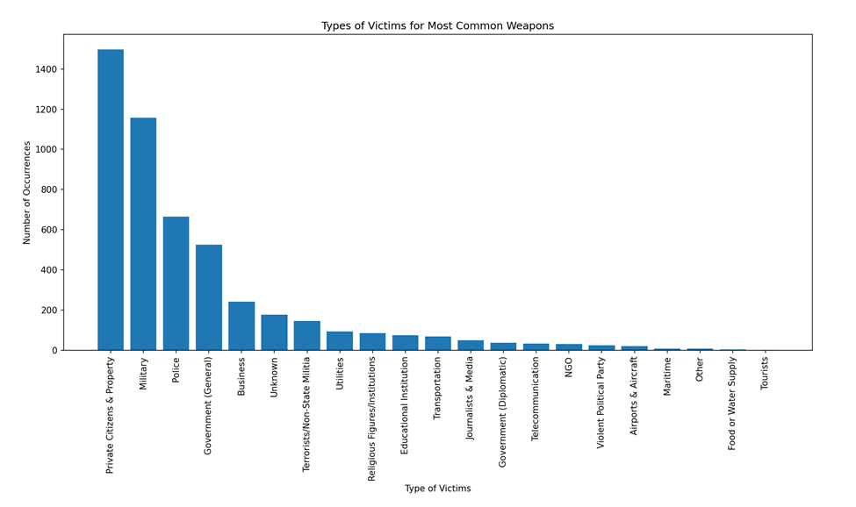

According to the latest graph, it can be claimed that the type of victims with the highest number of occurrences are private citizens & property.

To get clearer image of correlation, a new request to get the most common type of victim based on their nationality is examined:

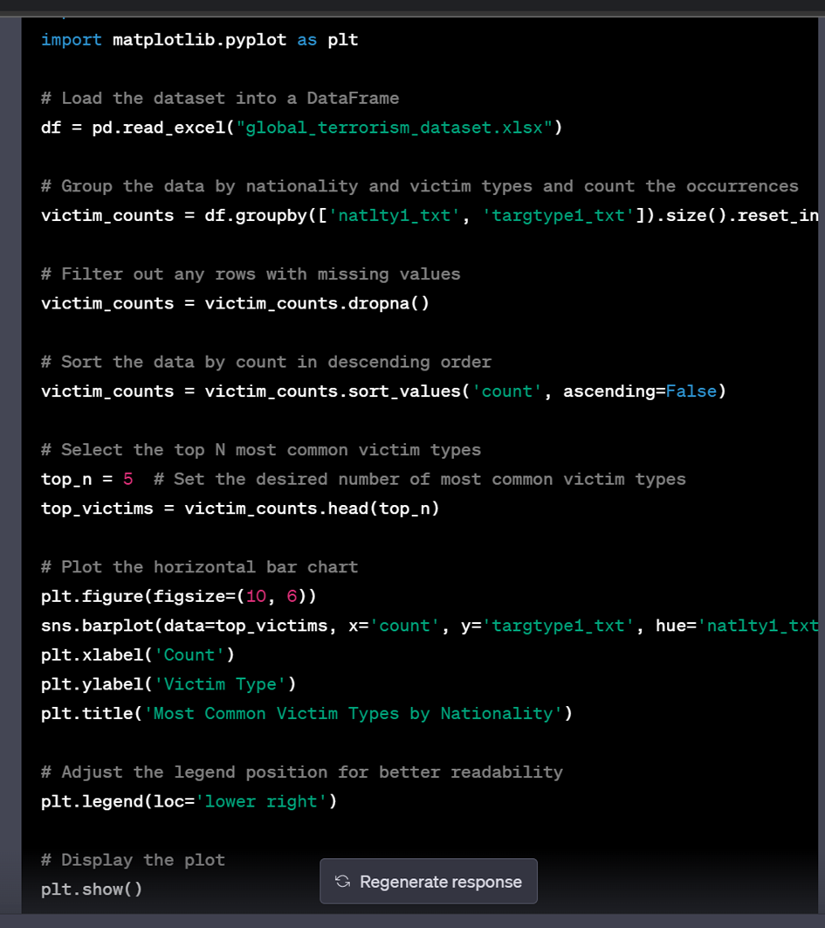

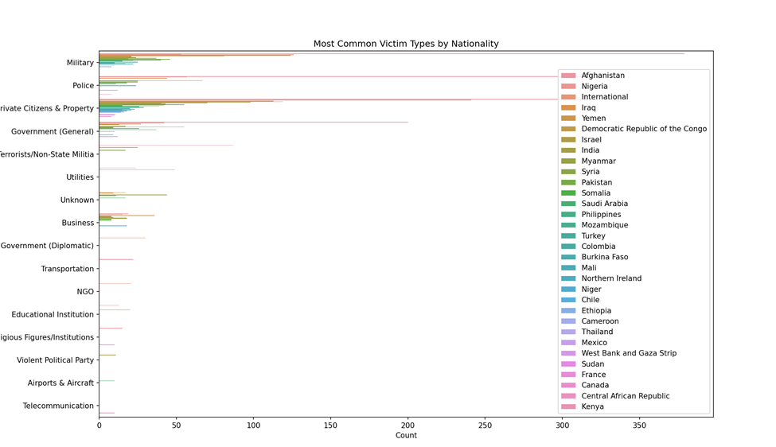

However, the generated graph lacks clarity in effective representation of the correlation for used weapons and victim types based on their nationality. Thus, for better representation of correlation, a new prompt, requesting for individual plots, showcasing the correlation between a certain type of weapon and certain type of victim (also elaborating on their nationality), is entered, and the results are received:

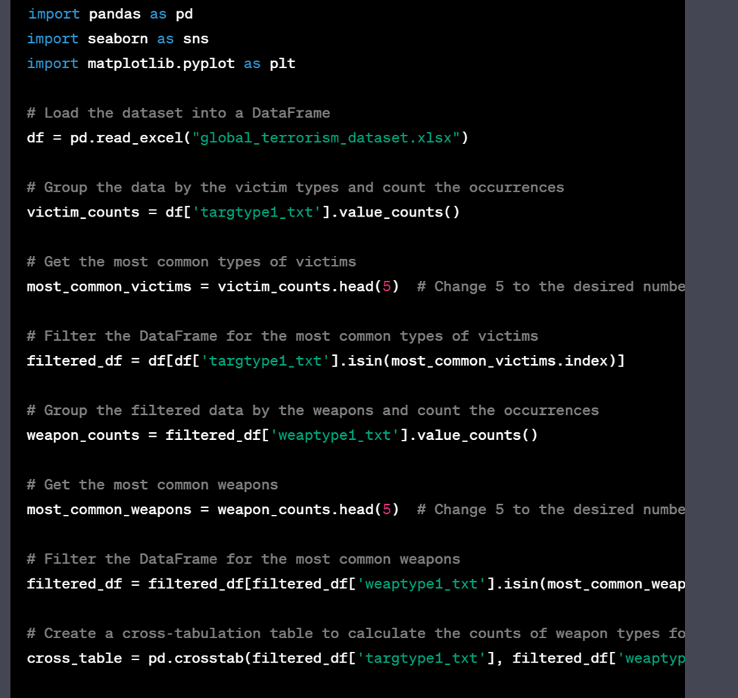

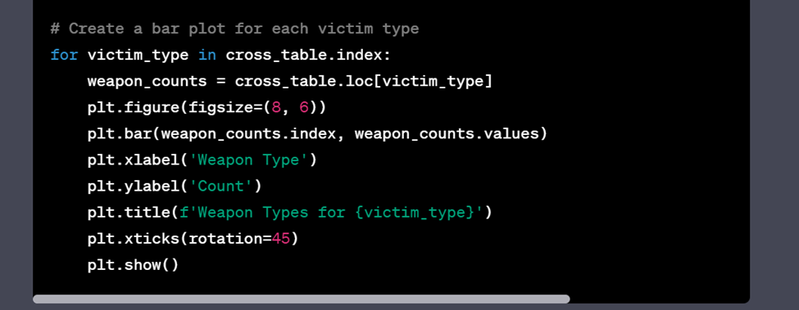

When executing the code in the PyCharm environment, it results in visualization of 9 separate graphs, which present the correlation of a particular weapon with the type of victim. They are combined in the next figure:

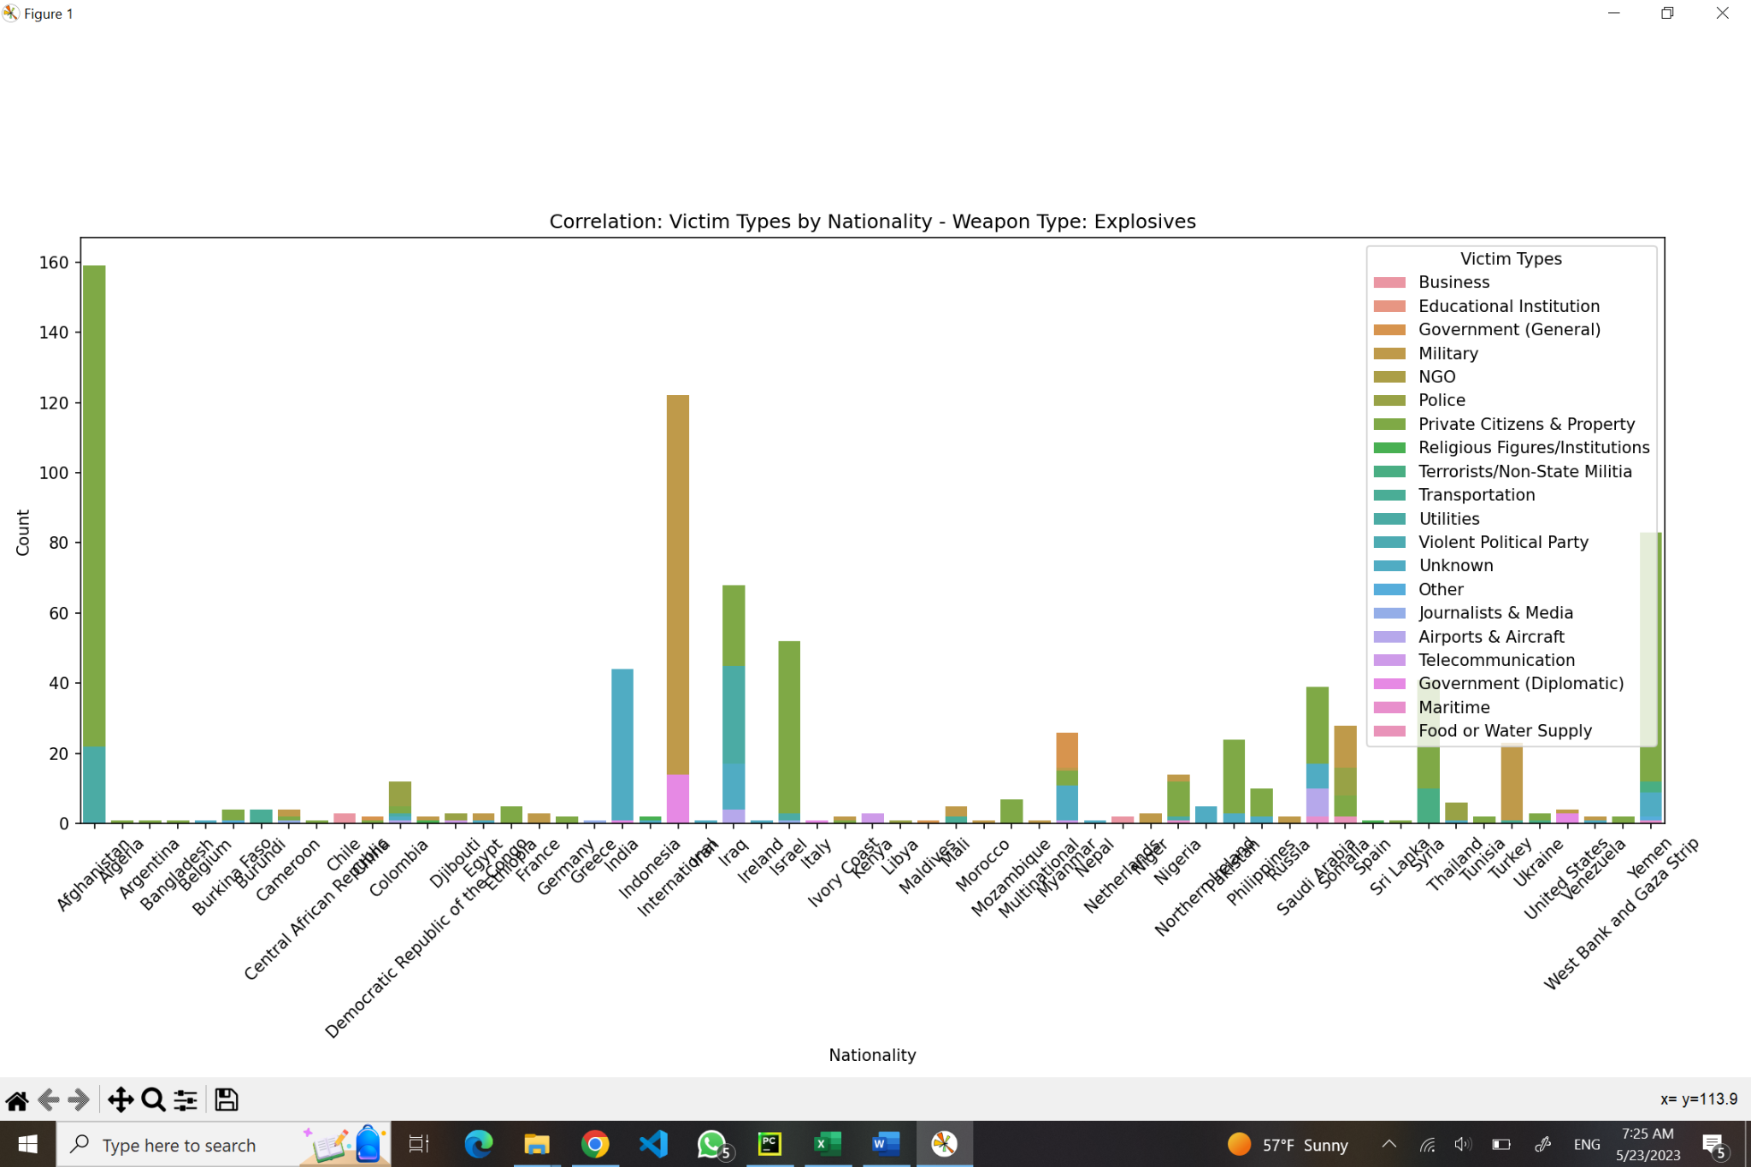

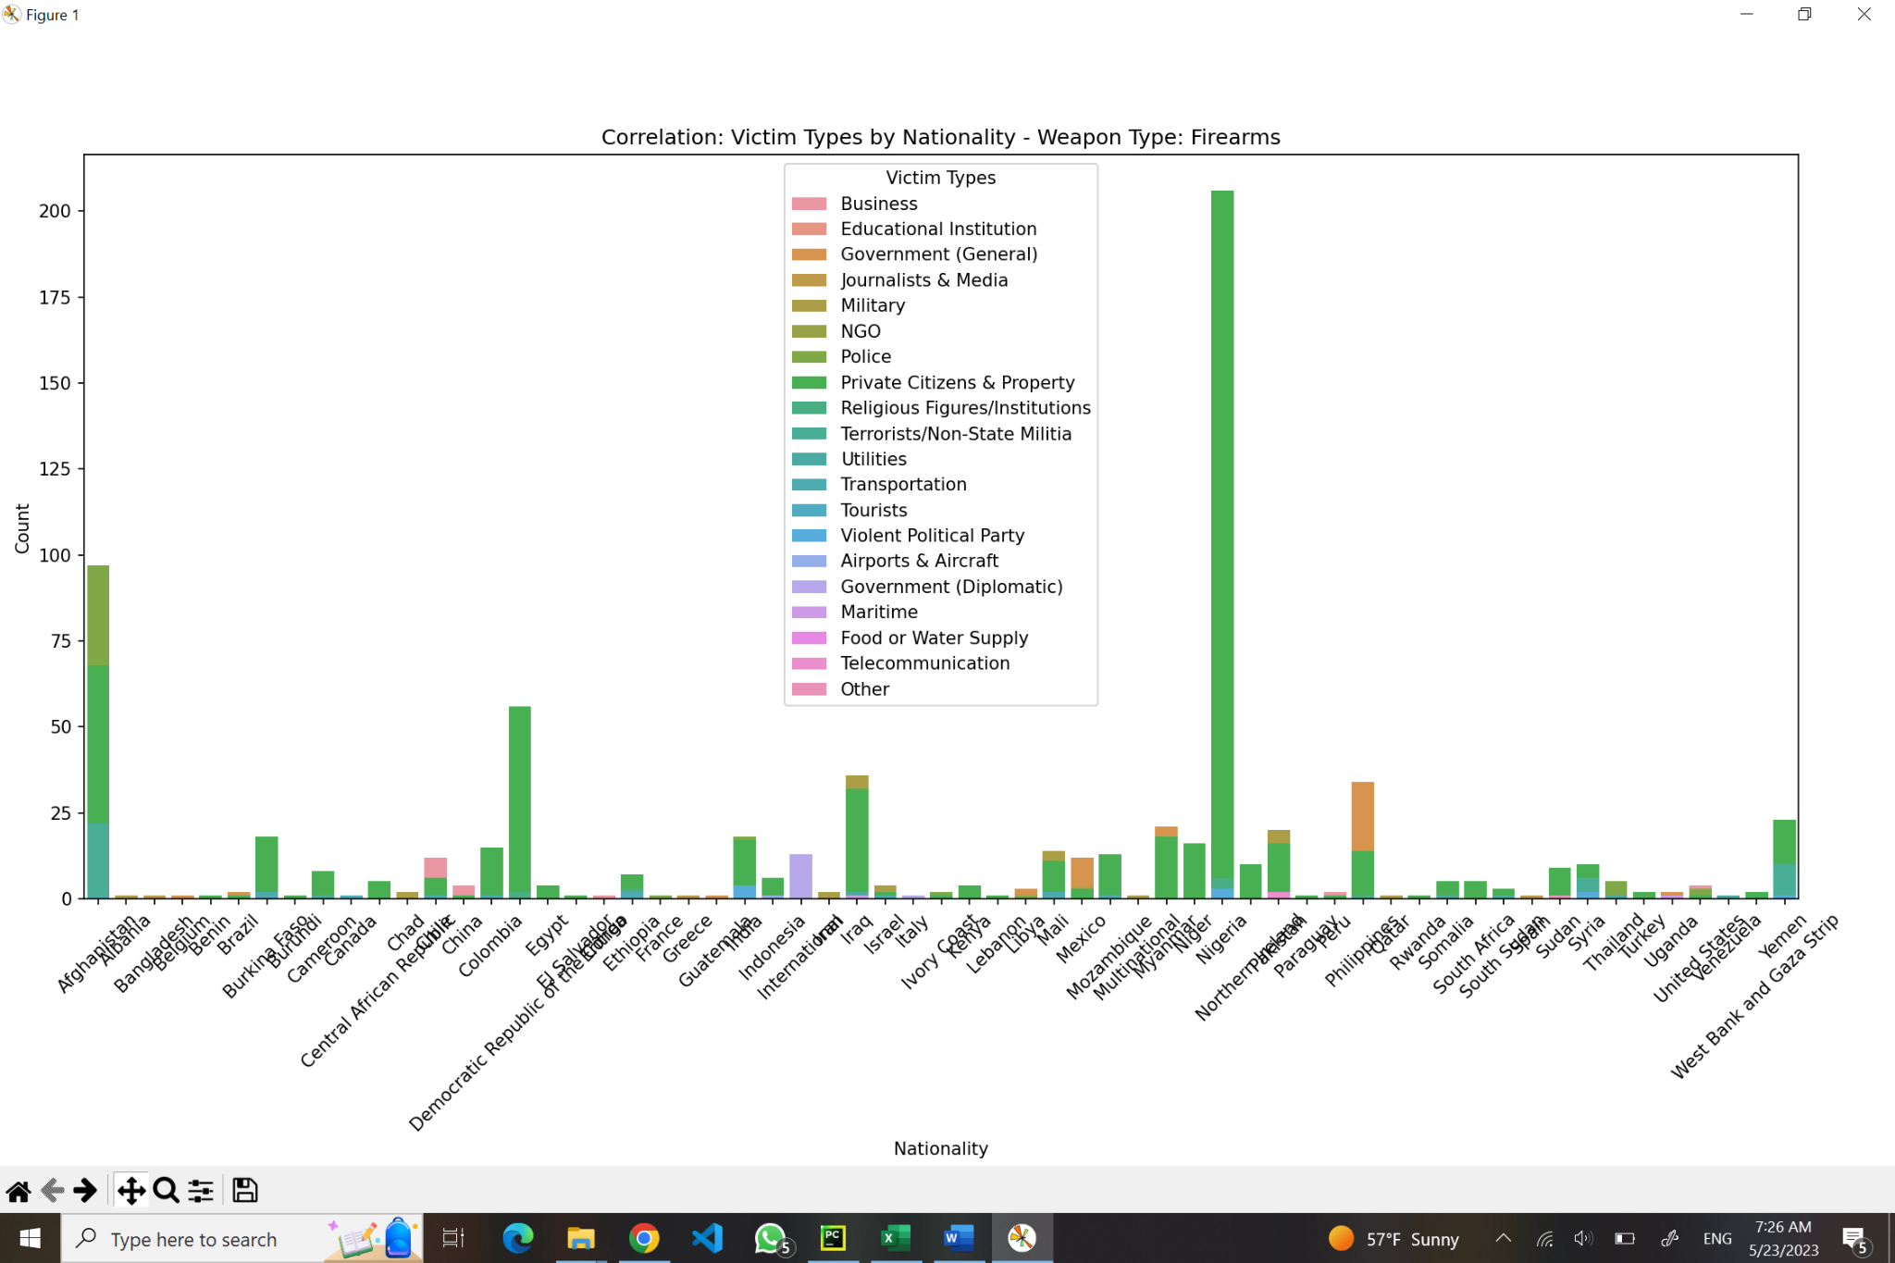

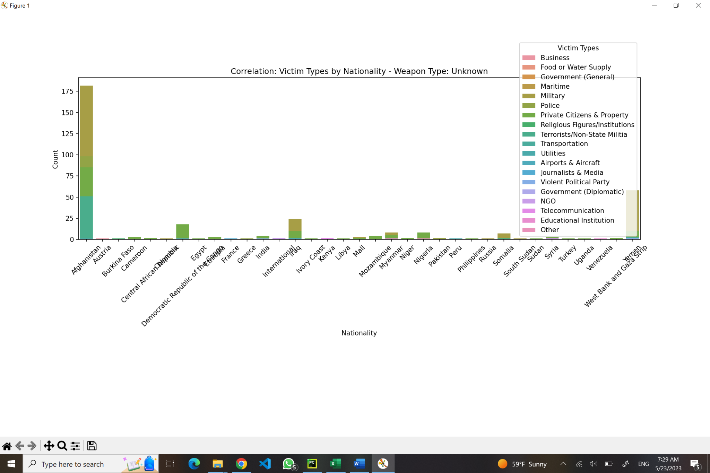

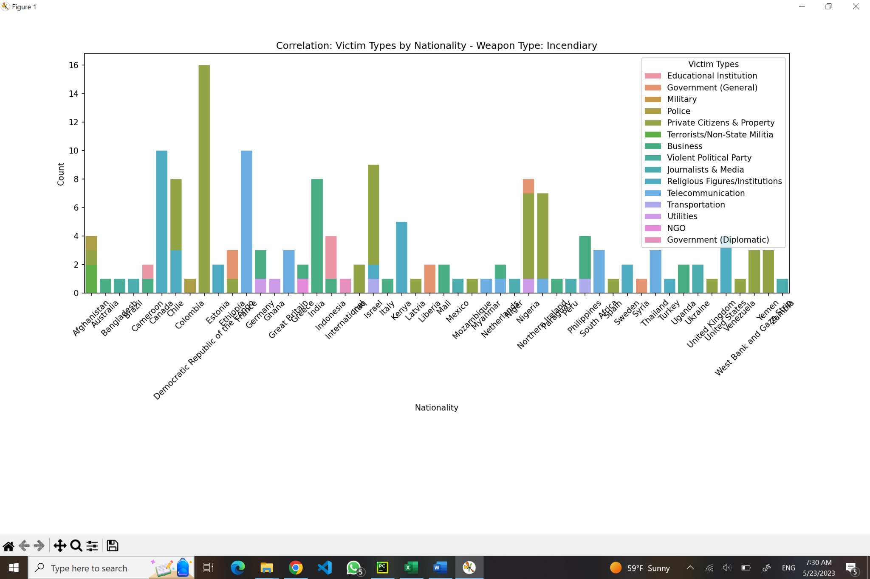

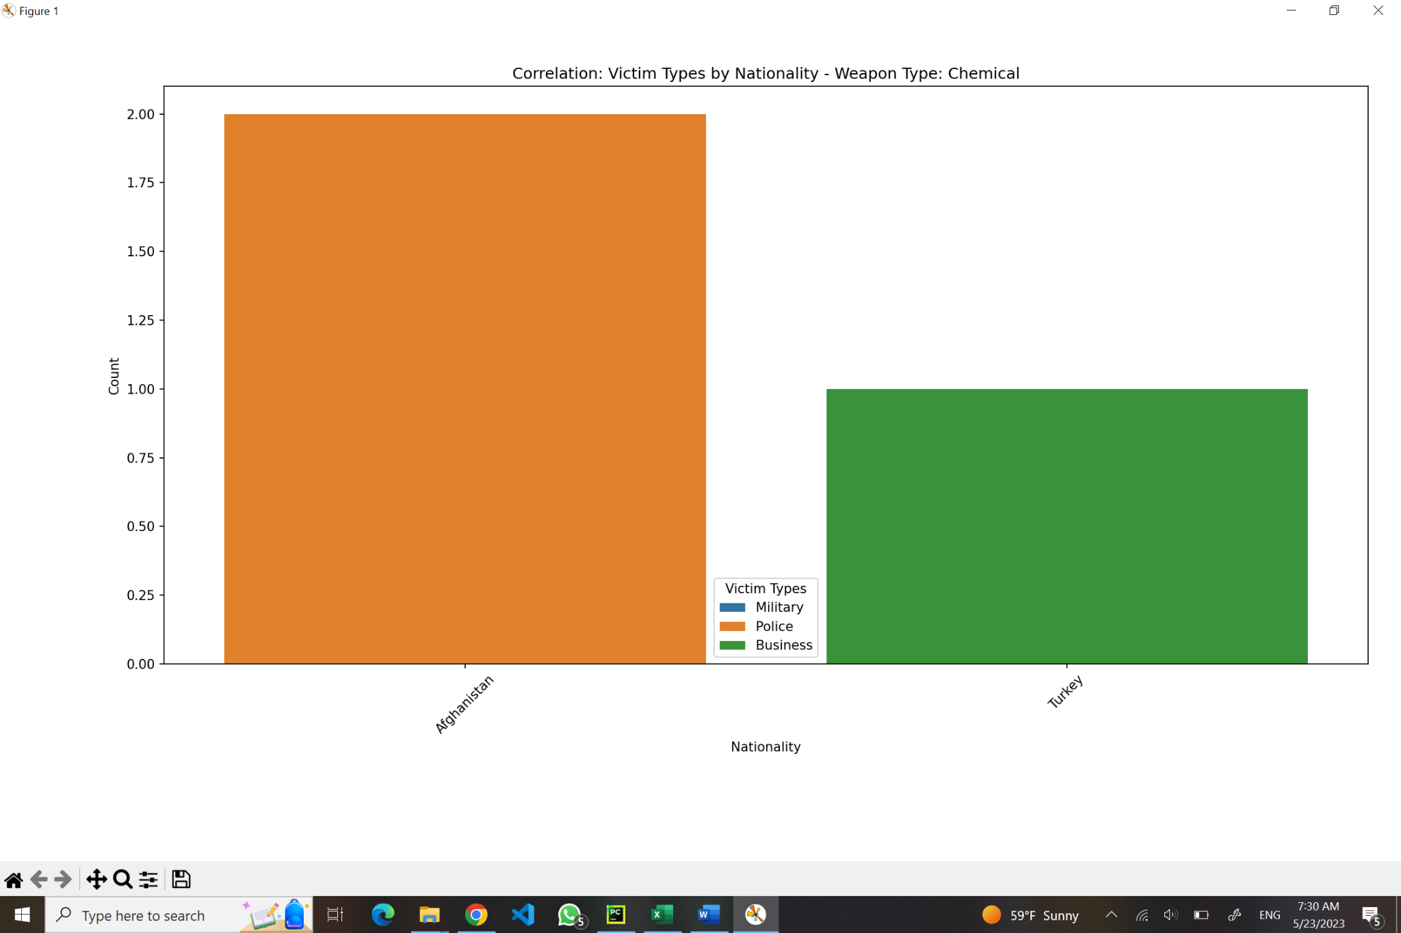

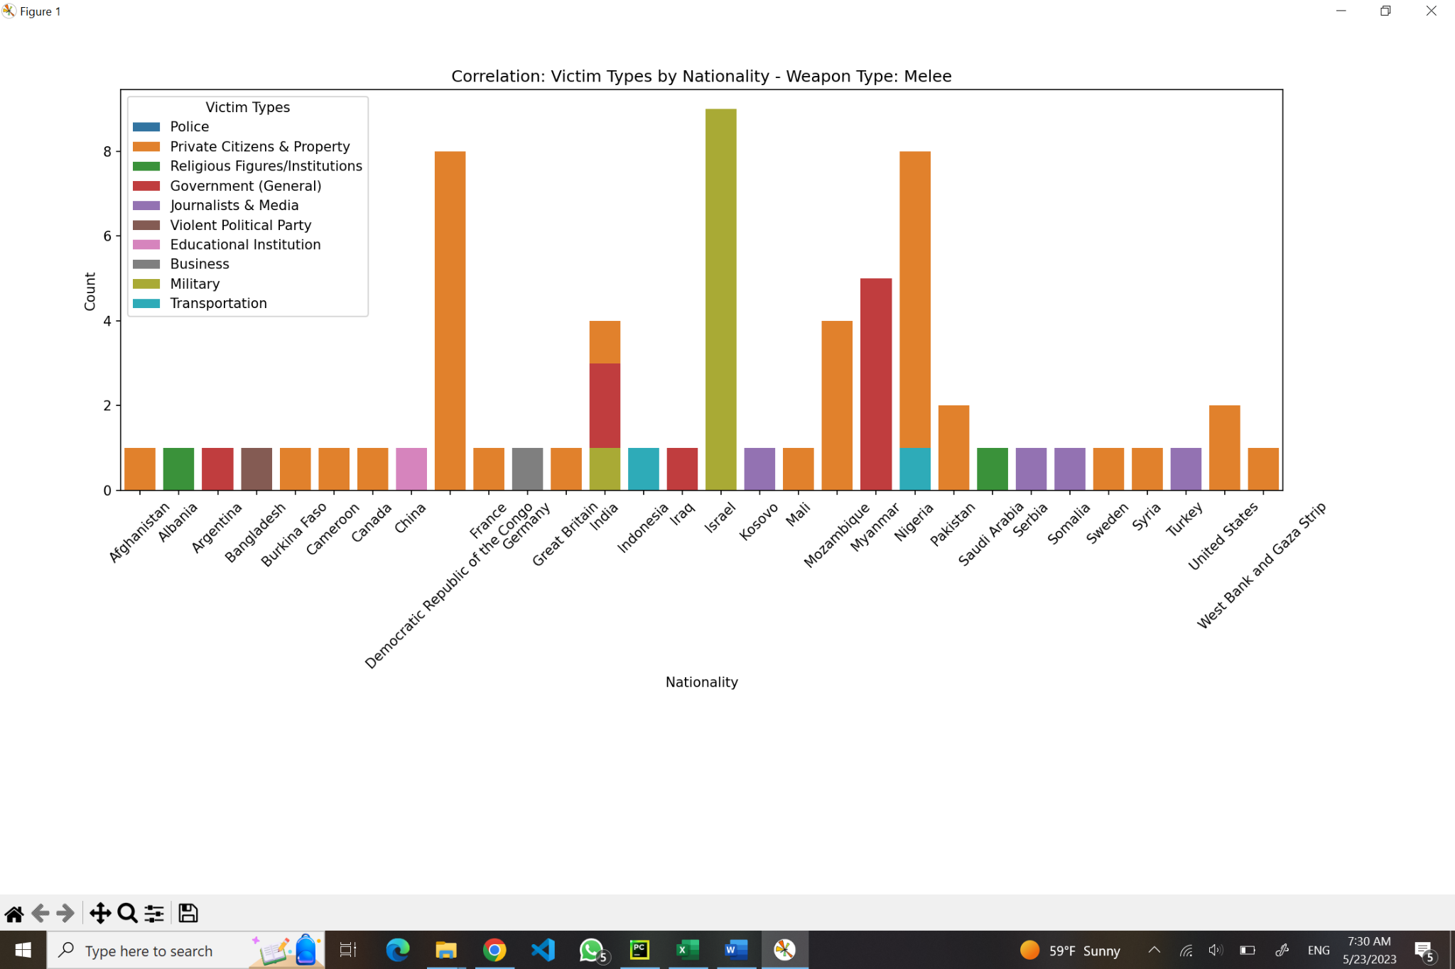

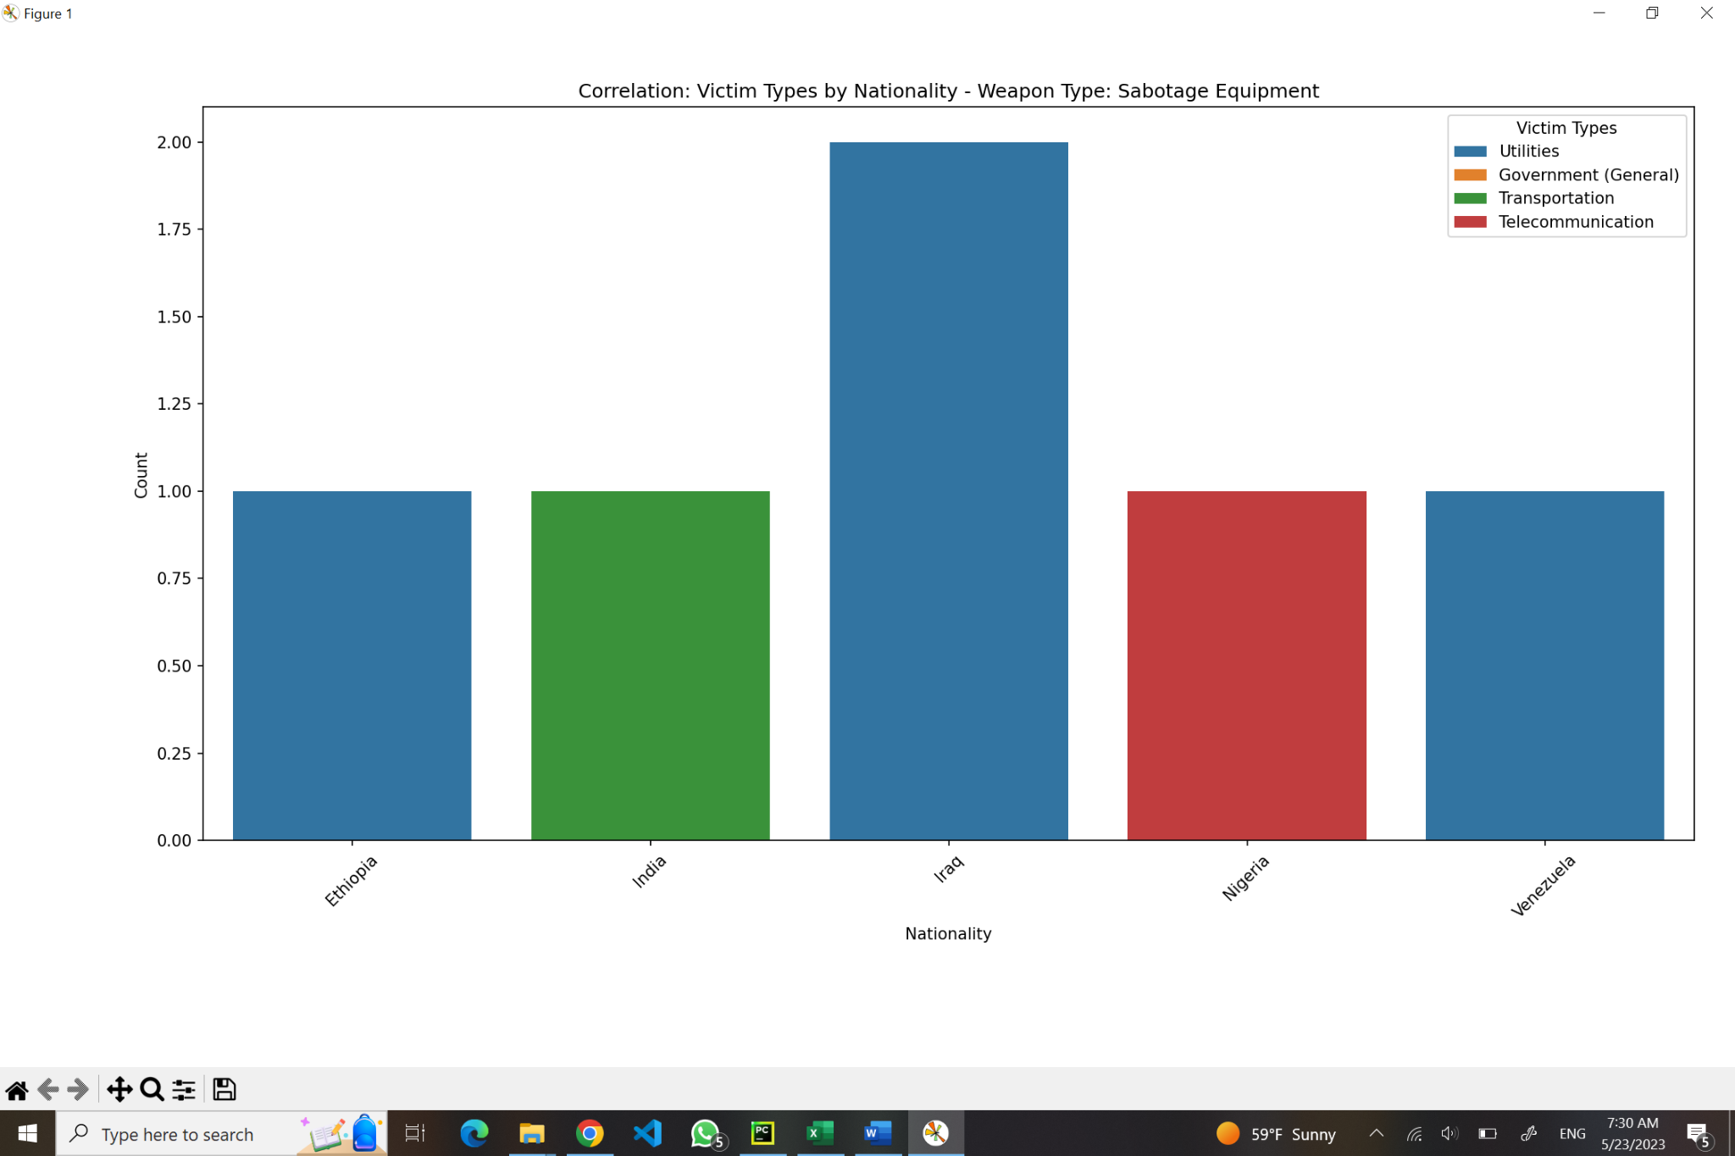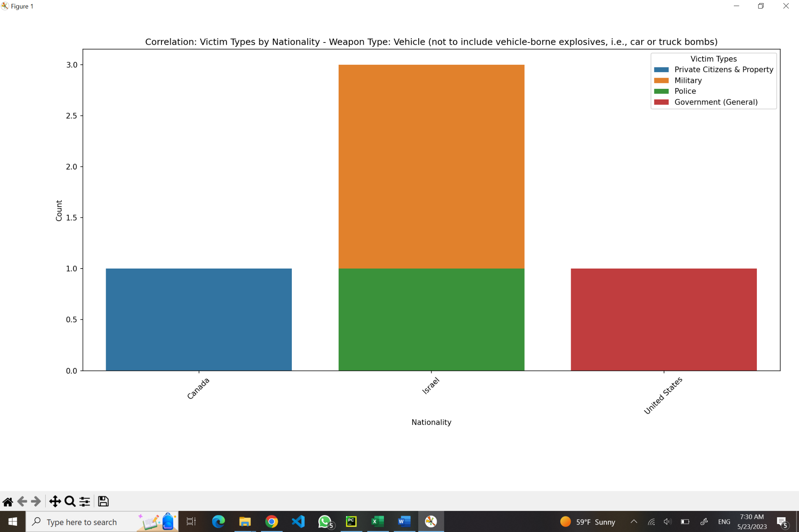

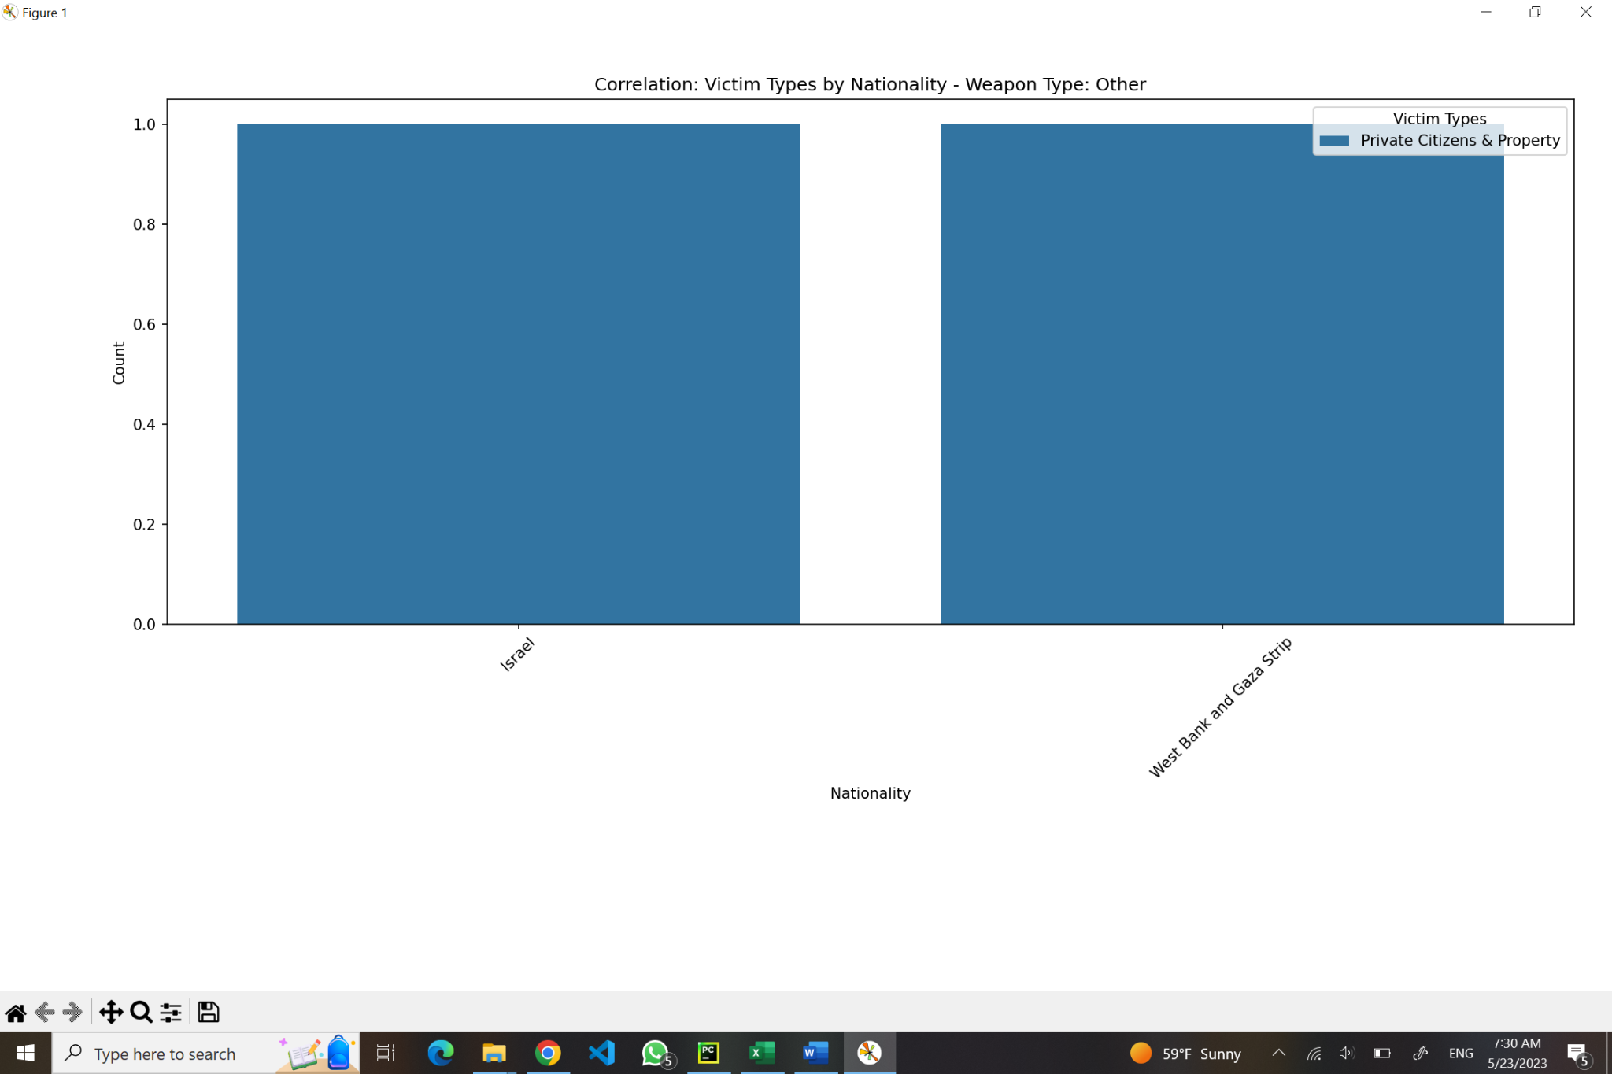

According to gathered information, certain observations based on nationality & occupation of a victim can be made (for example, explosive weapons are mostly being used in Afghanistan towards private citizens) and, relying on those analyses, certain actions can be taken to prevent those attacks.

## Correlation of location of attack and terrorist (group)

As a first prompt, to determine the correlation between the location of attack and terrorist group, the next prompt is getting examined: I have a Global Terrorism Dataset, with the columns of iyear, imonth, iday, country_txt, region_txt, city, latitude, longitude, location, attacktype1_txt, targsubtype1_txt, corp1, target1, natlty1_txt, gname, weaptype1_txt. What is the correlation between location of attack and terrorist (group)?”. After executing generated code, which is:

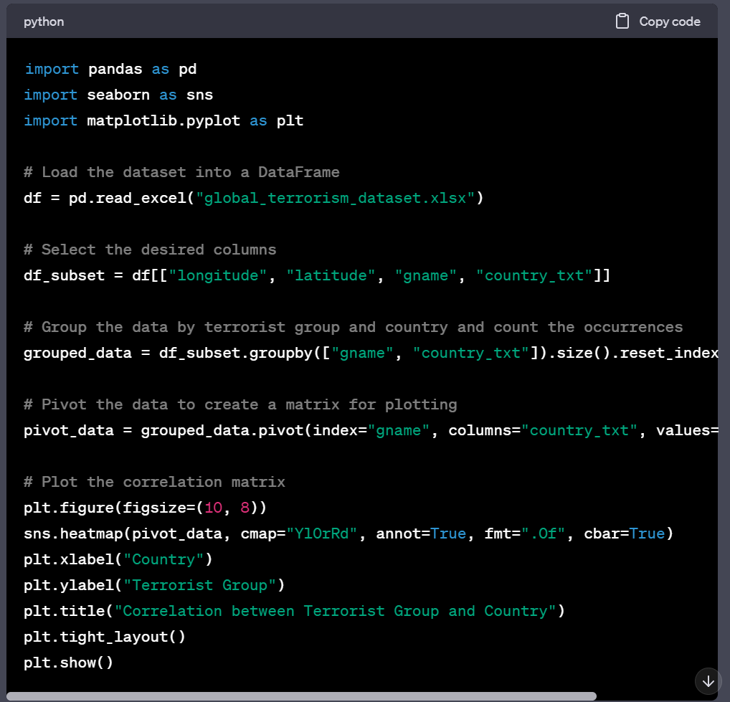

The PyCharm environment presents this output:

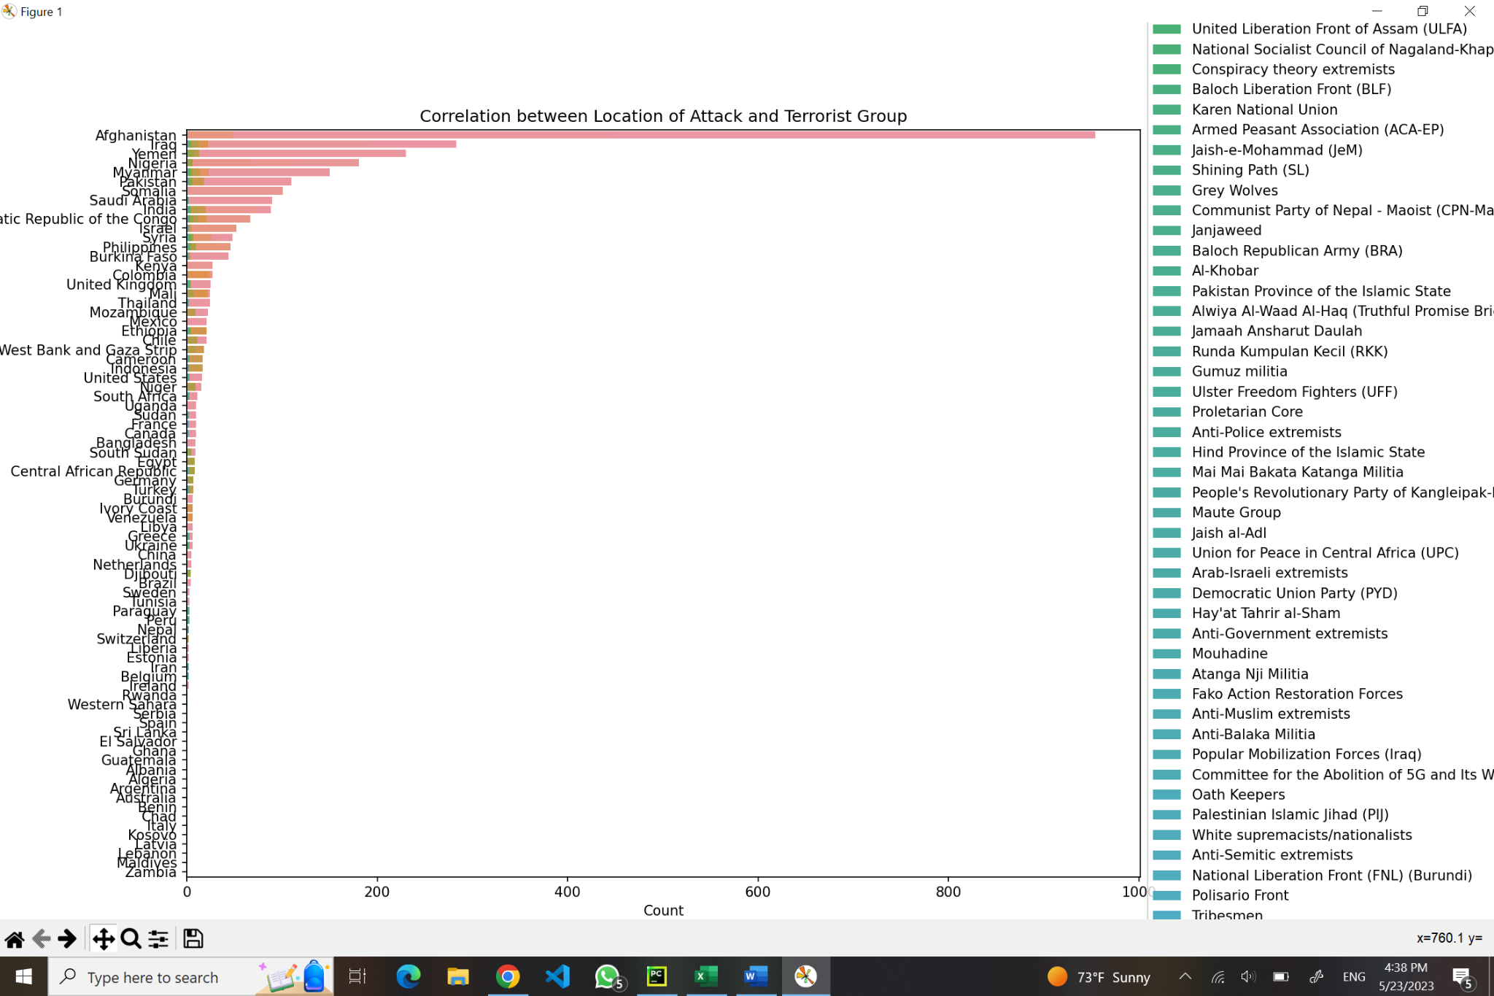

As it can be observed, the generated graph does not meet desired standards and lacks preciseness. To enhance its quality for better representation of correlation, the process of establishing the correlation gets divided into several parts. First of all, the code for the list of most common countries, based on the number of occured attacks, is required. The code and the result, accordingly:

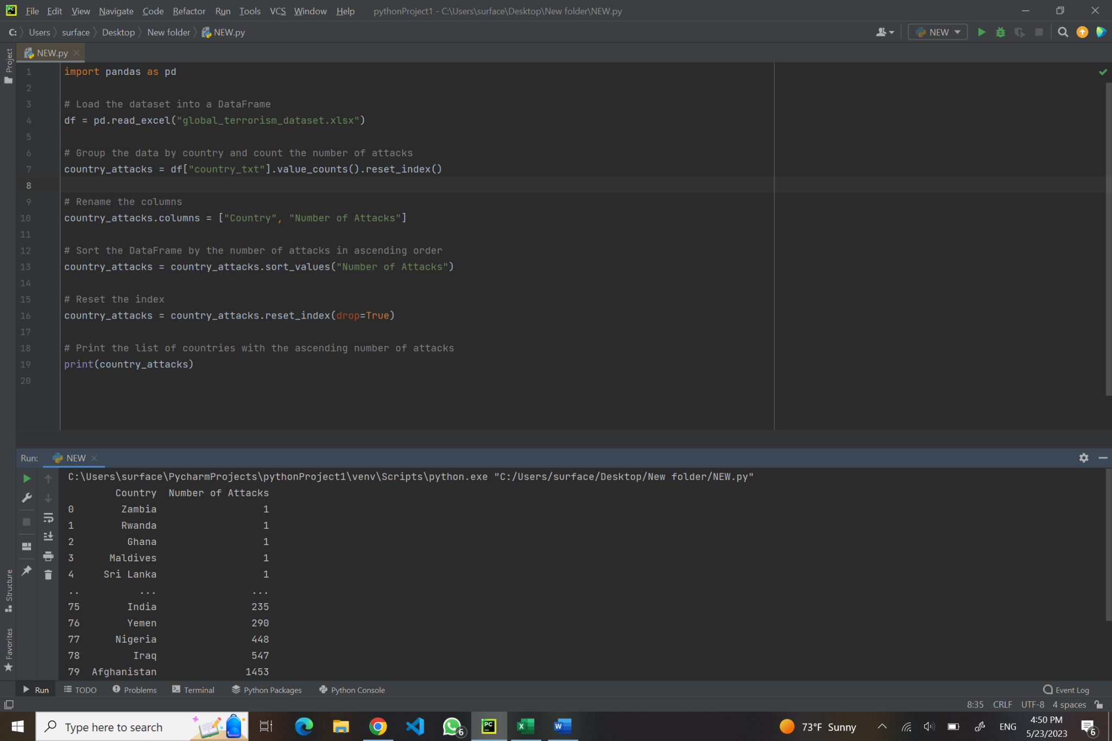

Secondly, similar request, which must present the list of the most common terrorist groups (in ascending order) is getting processed, and the output is:

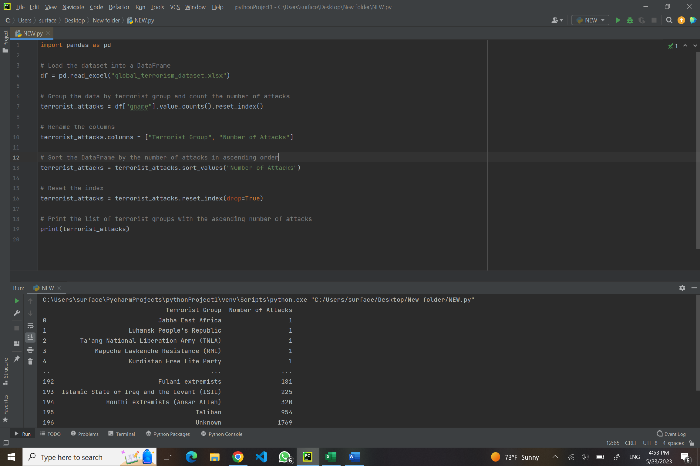

A few more patterns of correlation are getting examined:



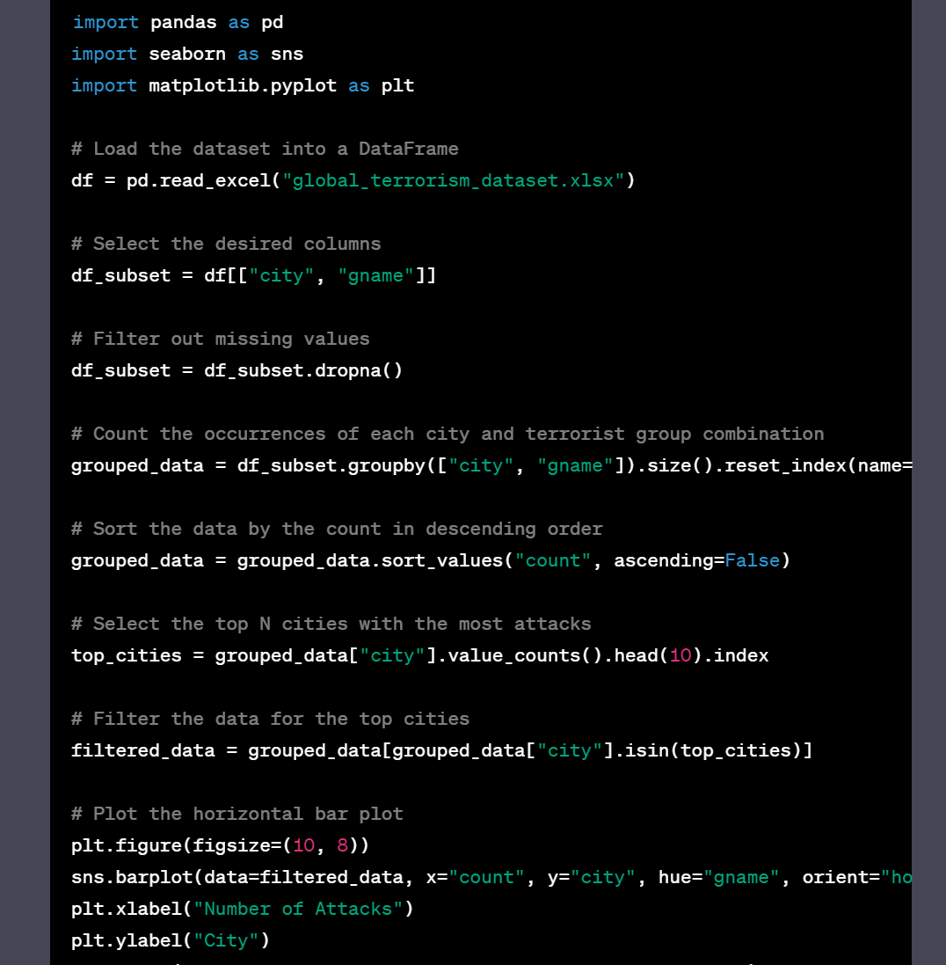

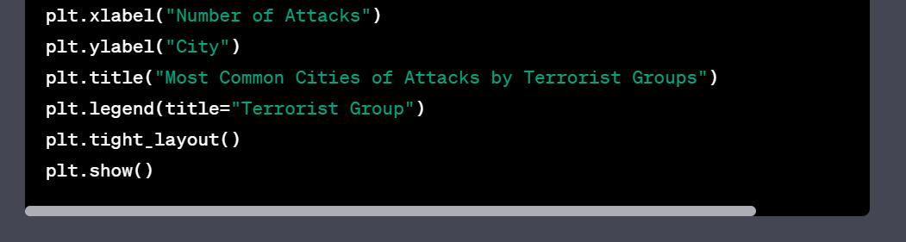

What results in the next visualization:

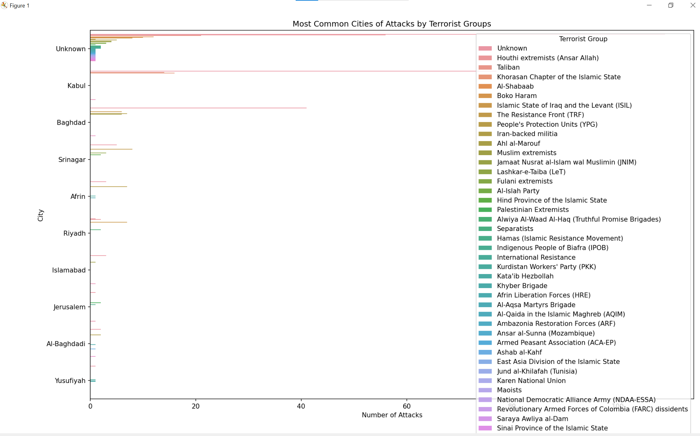

According to gathered information, it can be observed that Kabul has the highest number of terrorist attacks.

Additionally, one more code gets generated for establishment of the relationship between longitude & latitude and the terrorist group:

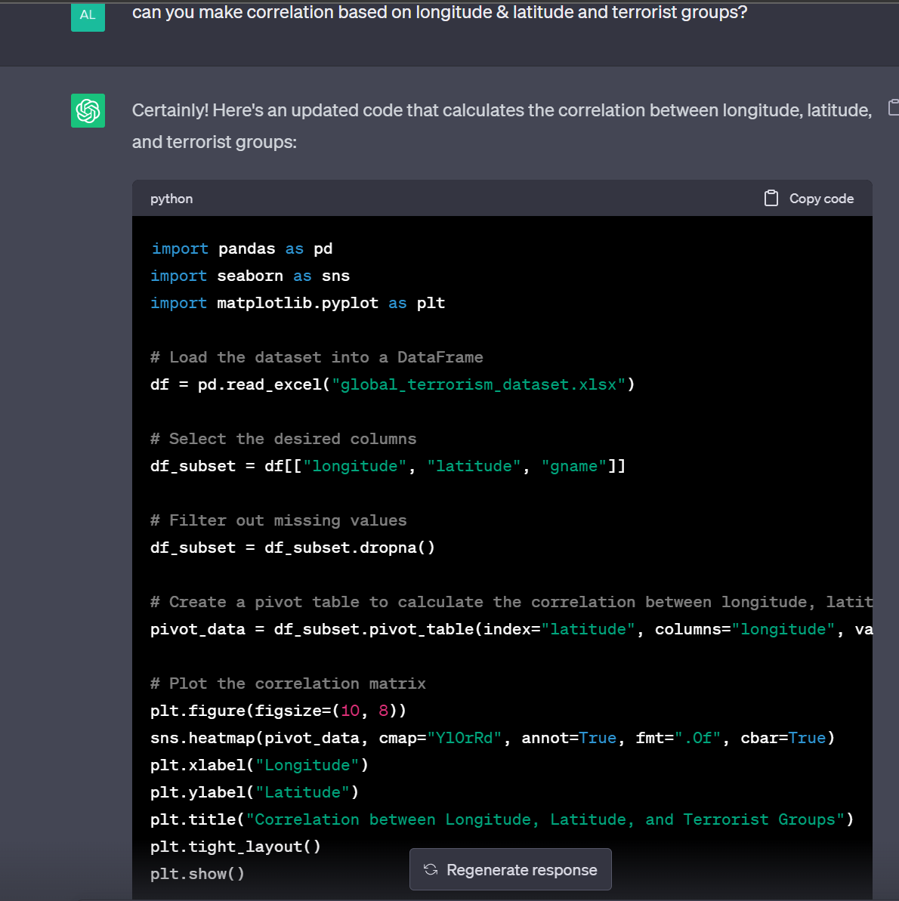

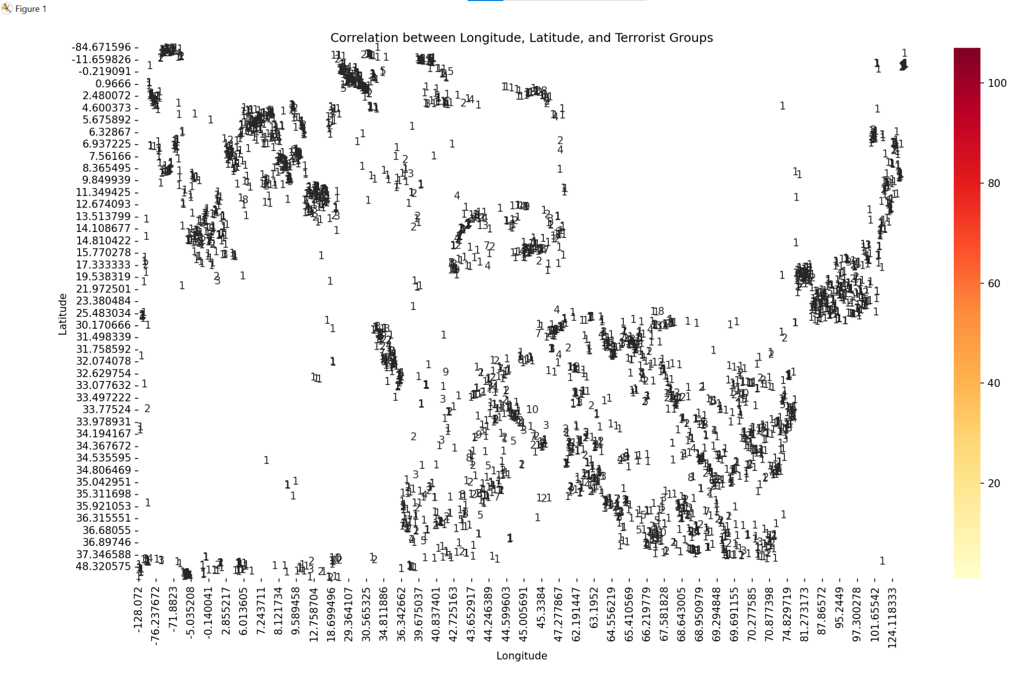

Inspecting this graph, certain conclusions can be made based on the geographical concentration of terrorist attacks and Identification of high-risk regions.

Thus, having accurate representation of the list of terrorist groups and locations, it is possible to establish more defined correlation:

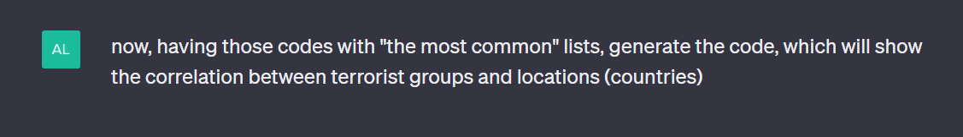

the outcome:

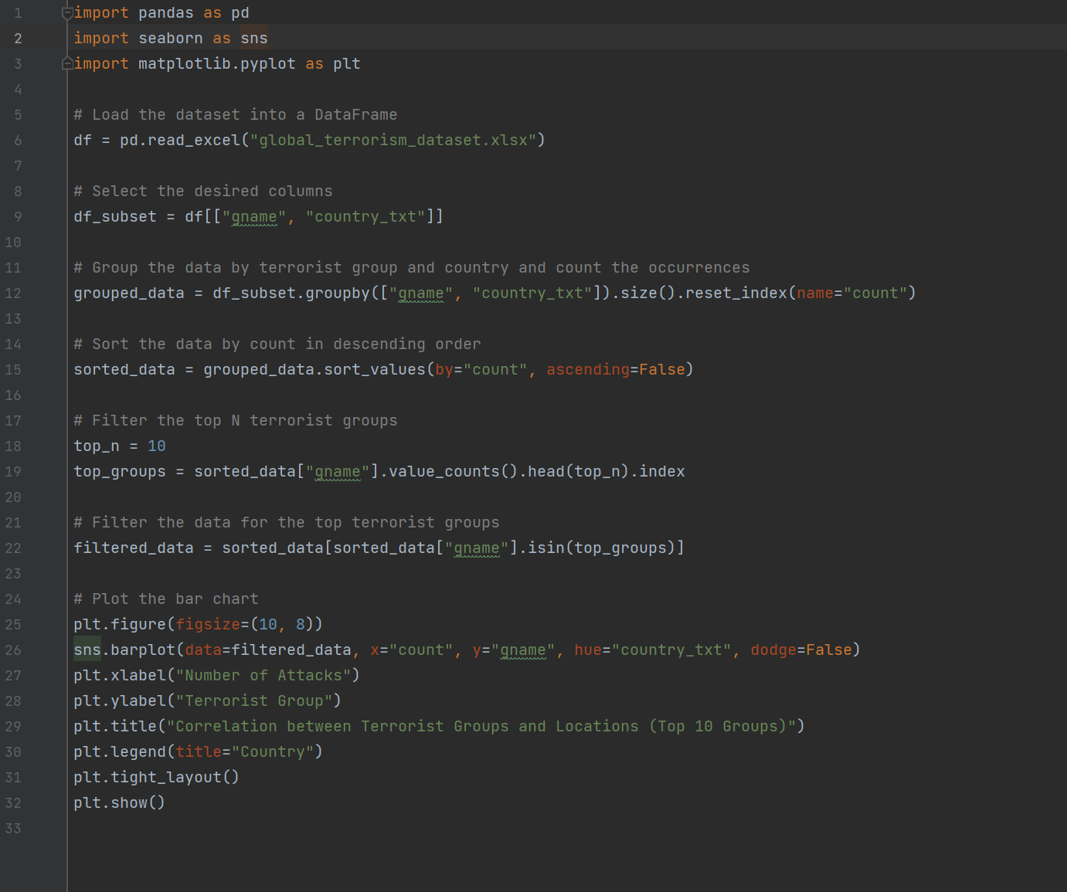

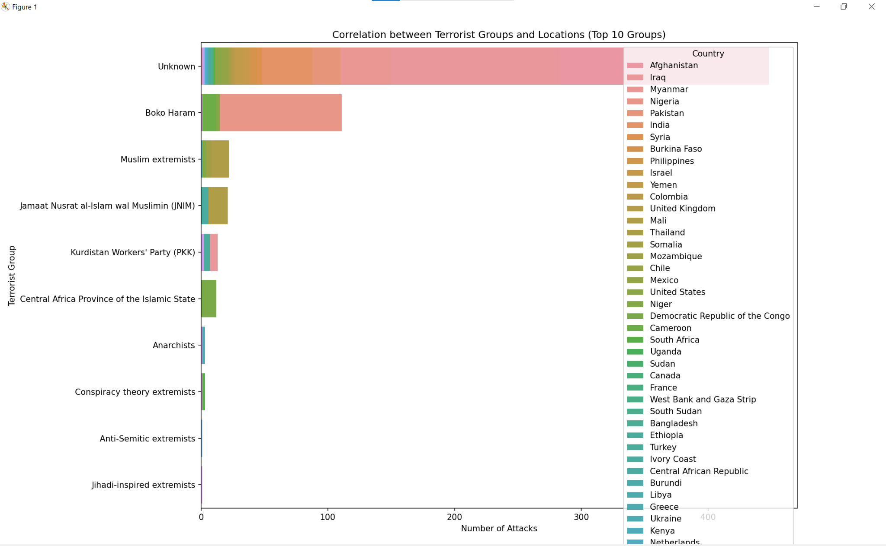

Based on the presented barplot, the top 10 most common terrorist groups with respective occurrences of attacks across countries can be observed. The graph provides relevant insights into the correlation patterns of geographical distribution of terrorist organizations. When scrutinizing this barplot, certain conclusions can be made - for example, terrorist group “Boko Haram” has the most occurrences in Nigeria; the results of this study can be effectively used for in-depth investigation of counterterrorism actions, based on the relation of particular country and particular terrorist group.

## Correlation of terrorist (group) and type of weapon used

Link to Jupyter Notebook:

<https://github.com/bda-anaconda/bdateamproject/blob/main/correlation_terroristgroup_weapon.ipynb>

As a first step, it was inspected whether there is a correlation between the terrorist group and the weapon used in the attack. In order to do that the chi-square test was performed and Cramér’s V was calculated. The chi-square test evaluates whether there is a significant relationship between two categorical variables by measuring the distance between observed and expected frequencies under the assumption of independence. Cramér’s V is based on the chi-square test measuring the intensity of the association where 0 indicates no association and 1 perfect association:

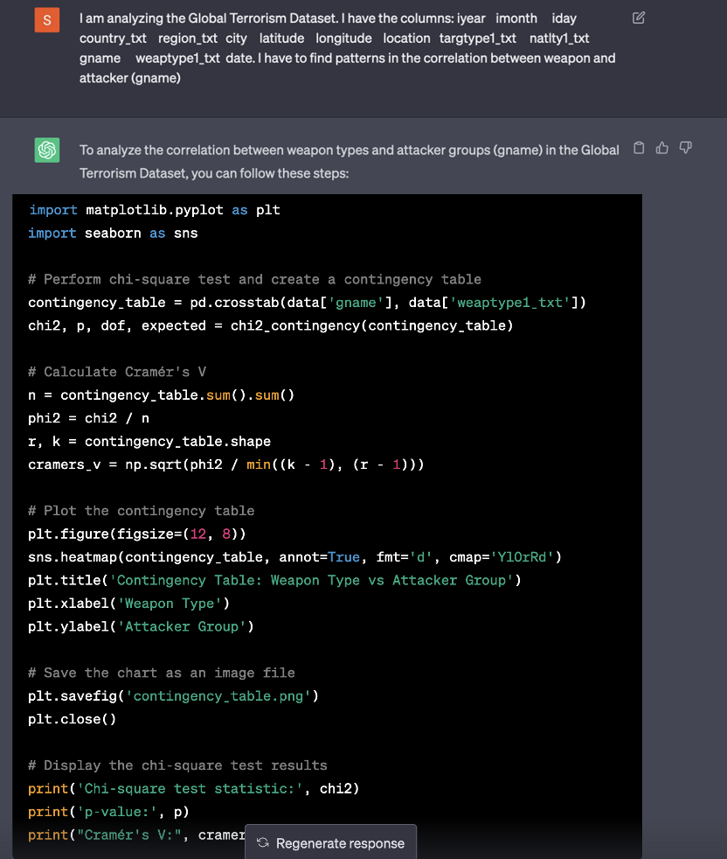

*Figure 22: Prompt to show correlation between attacker group and weapon*

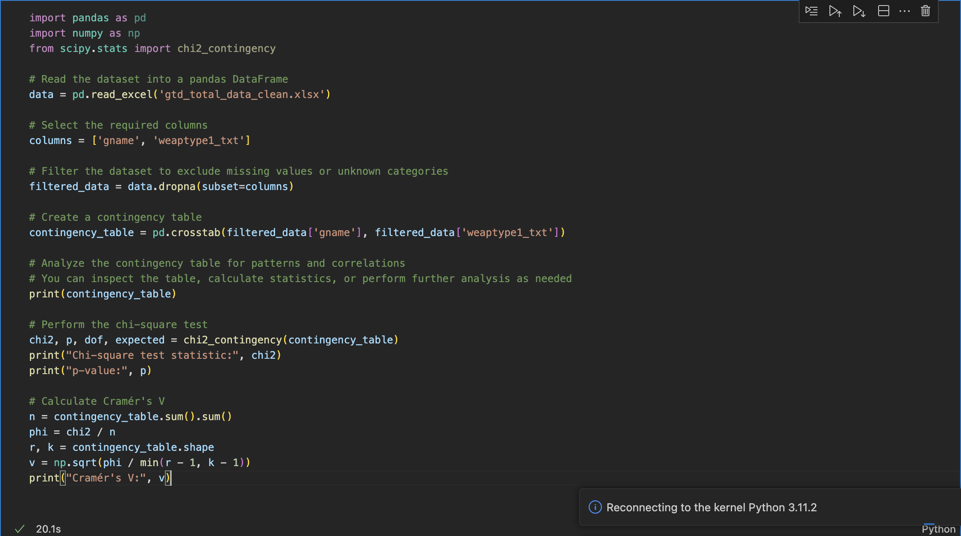

*Figure 23: Python code to show correlation between terrorist group and weapon*

First, the needed columns, ‚gname’ and ‘weaptype1_txt’ were selected. To increase the performance, all other columns were dropped. A contingency table was created to show the distribution of the variables. Then the chi-square test was conducted by using the chi2_contigency function of the module scipy.stats. After that, Cramér’s V was calculated. Following output was created:

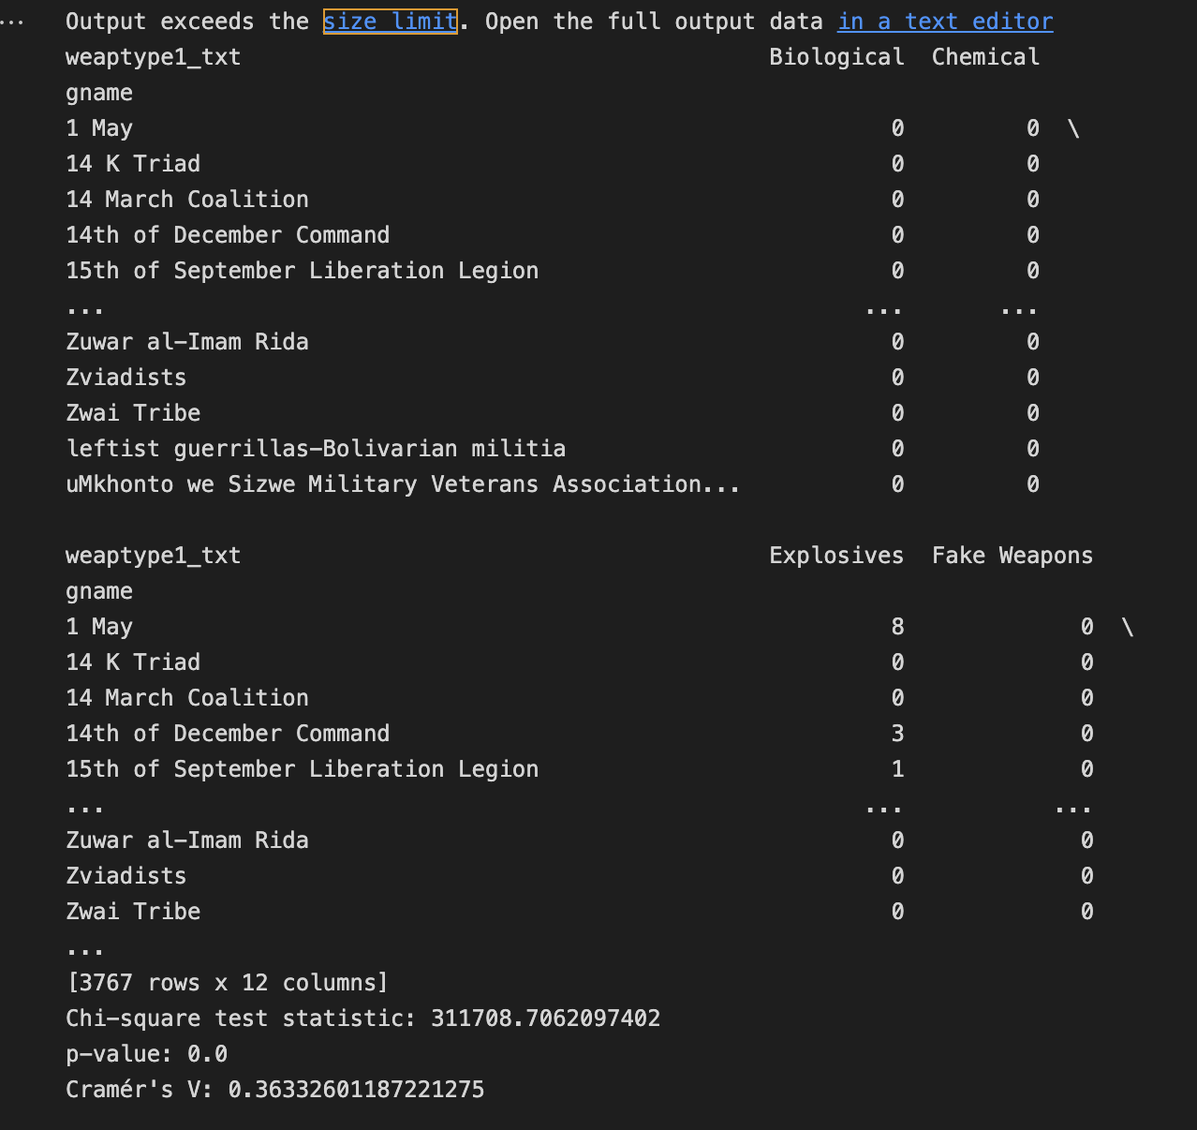

*Figure 24: Correlation between terrorist group and weapon*

The contingency table is a little confusing since there are a lot of terrorist groups. That’s why in the next step, we will only focus on selected groups. The result of the chi-square test indicates that there is a correlation between terrorist groups and weapons used. The p-value shows strong evidence towards a rejection of the null hypothesis. Cramér’s V shows however, that the correlation is there, but not very strong.

In the next step the most active terrorist groups as well as the number of incidents in the last 15 years were evaluated:

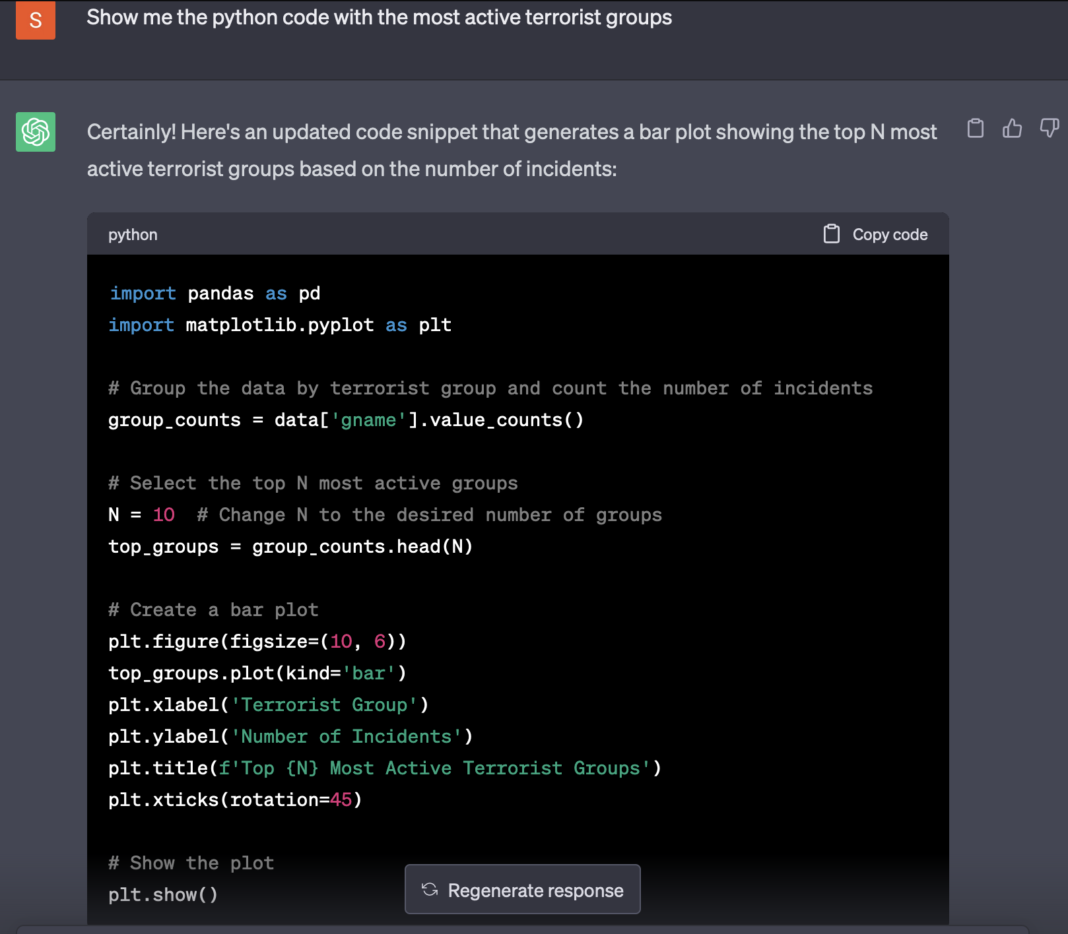

*Figure 25: Prompt most active terrorist groups*

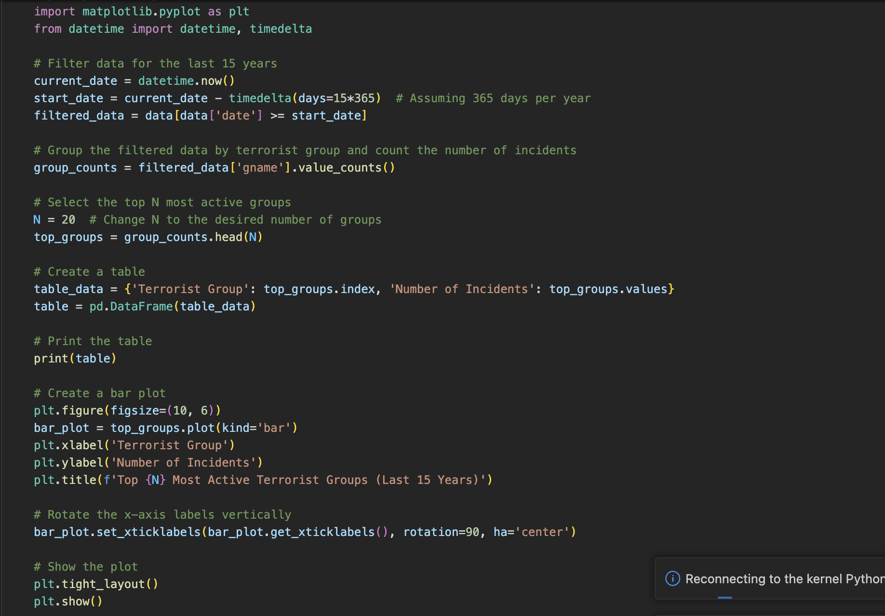

*Figure 26: Python code for 20 most active terrorist groups in the last 15 years*

Using matplotlib.pyplot, the number of attacks of the 20 most active terrorist groups in the last 15 years were visualized in a bar chart. Additionally, the exact numbers were printed:

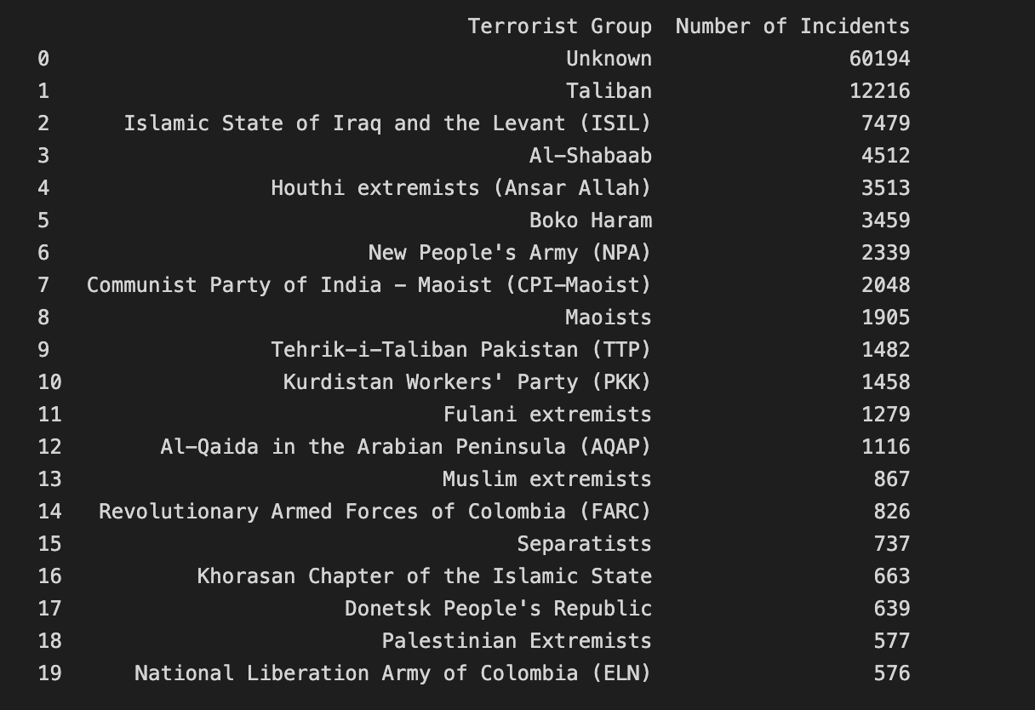

*Figure 27: 20 most active terrorist groups in the last 15 years*

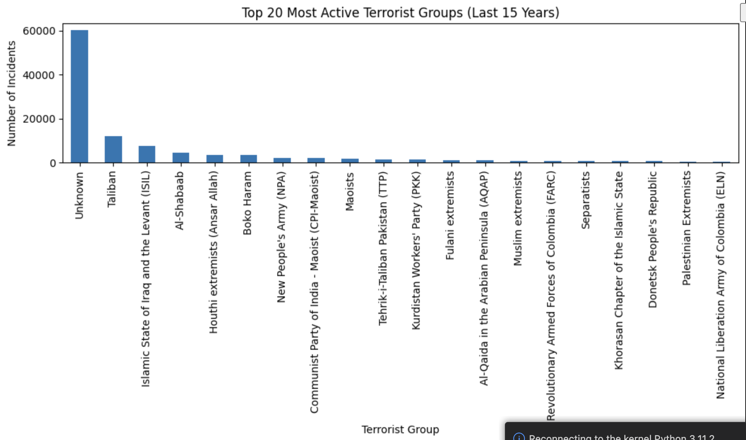

*Figure 28: Visualization of 20 most active terrorist groups in the last 15 years*

The result shows that for most attacks the terrorist group remained unknown.

This result was then set into correlation with the weapons used. For each of the groups the most used weapon was evaluated:

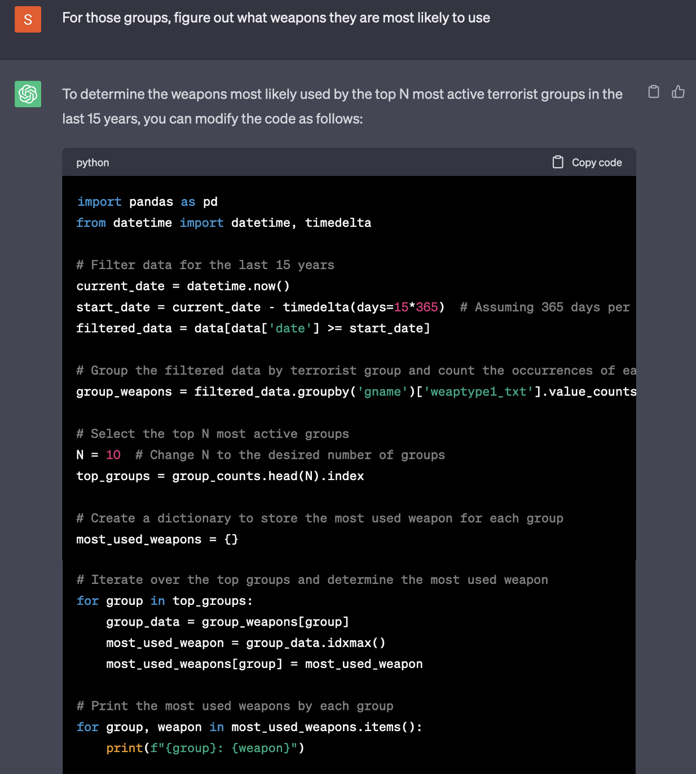

*Figure 29: Prompt for most used weapons*

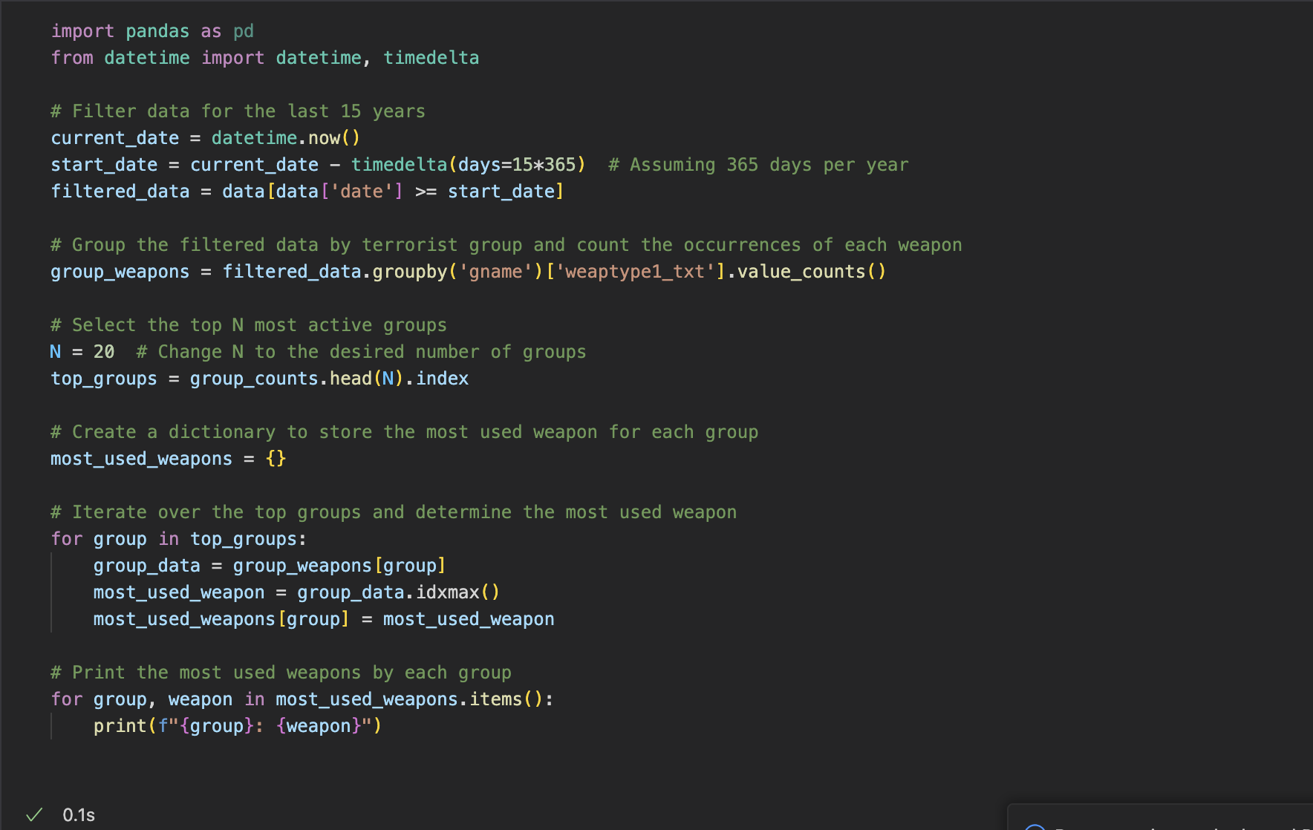

*Figure 30: Python code for most used weapon by the group*

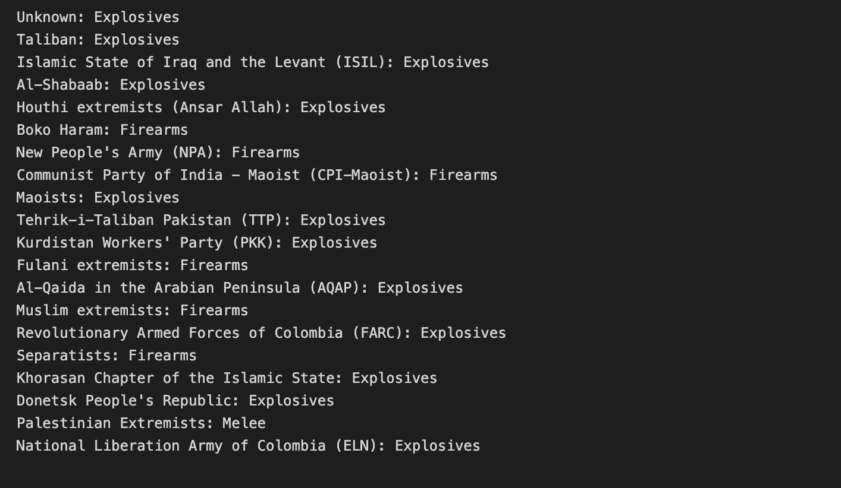

*Figure 31: Most used weapon by the most active terrorist groups in the last 15 years*

It is apparent that firearms and explosives are often used as a main weapon choice by the groups. To get further insights, the top 5 most used weapons per group were evaluated and plotted:

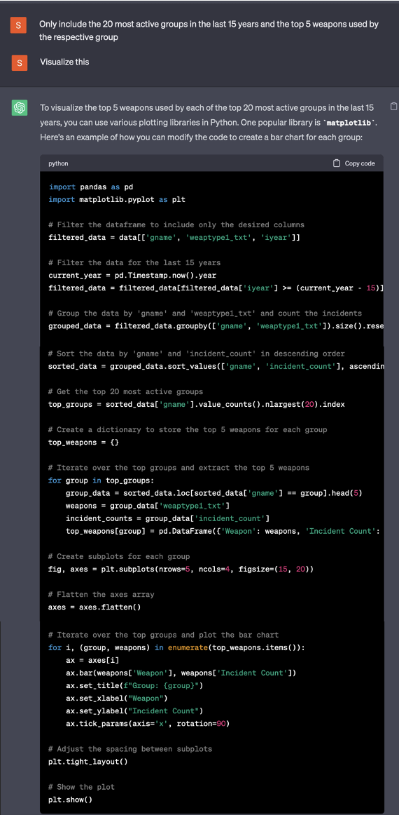

*Figure 32: Prompt to determine and visualize the top 5 most used weapons by the most active terrorist groups in the last 15 years*

Following python code was used to create the visualizations:

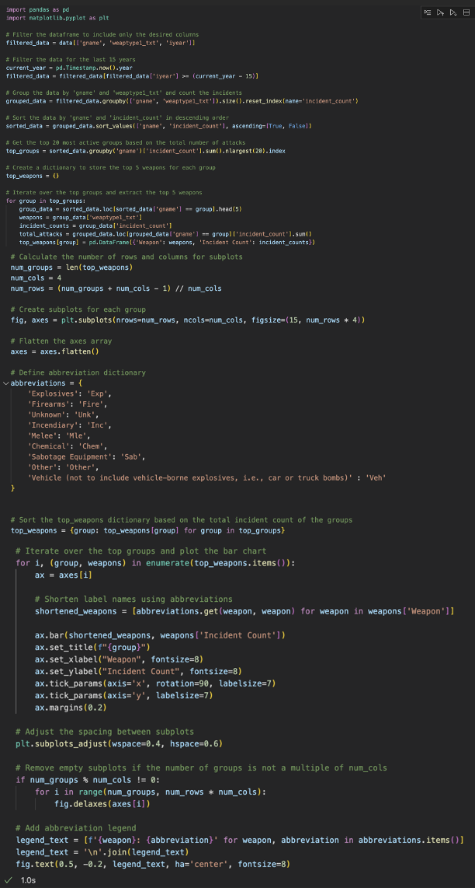

*Figure 33: Python code to determine and visualize the top 5 most used weapons by the most active terrorist groups in the last 15 years*

The data was grouped by terrorist group and weapons, then sorted to make the graphs appear in descending order of total attacks. Then, an iteration over the grouped results determined the top five weapons of the respective terrorist groups. The number of attacks made using the weapons is also determined. Because the labels kept overlapping, abbreviations were introduced and later, also a legend is added. The distance between the subplot is also increased so that nothing overlaps:

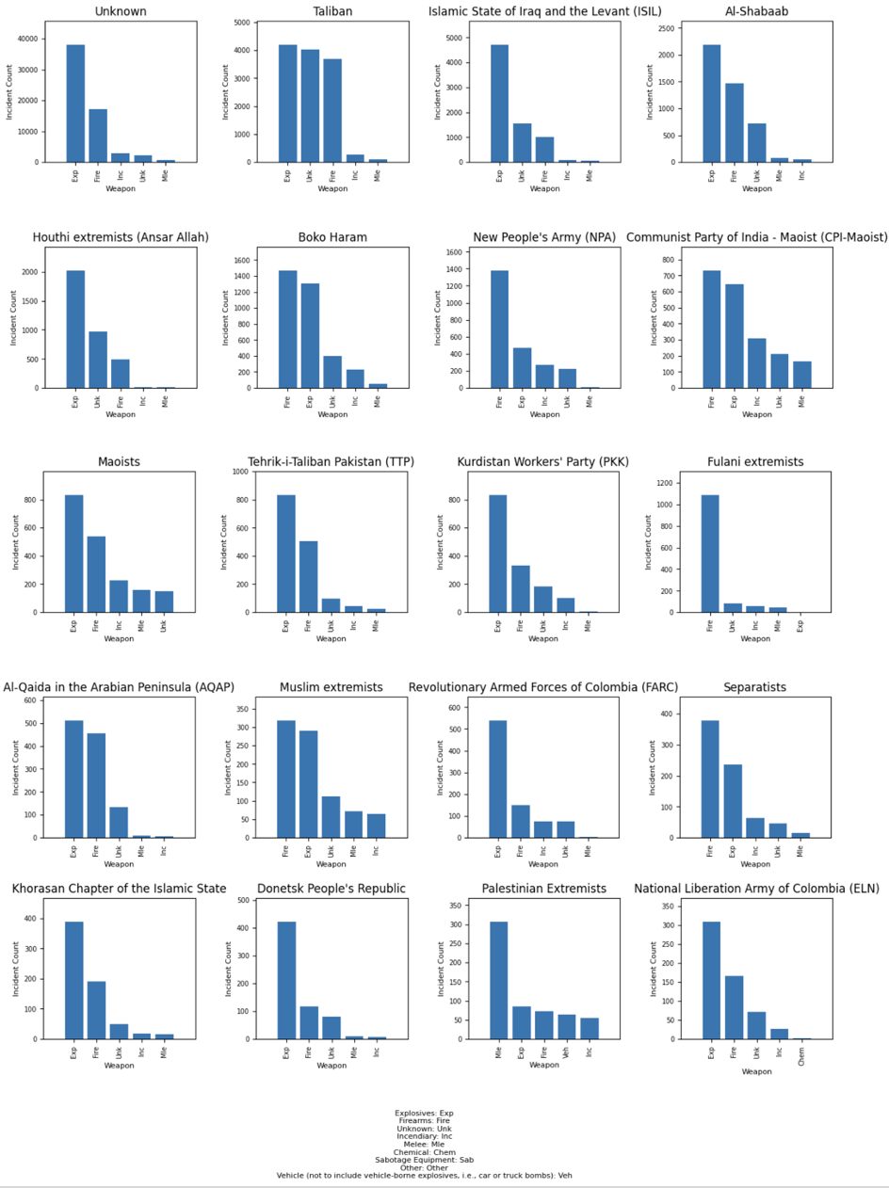

*Figure 34: Visualization of the top 5 most used weapons by the most active terrorist groups in the last 15 years*

The graphs show that besides firearms and explosives, incendiary, melee, chemical, sabotaged equipment, or vehicles are often used by the most active groups. Some groups also try to make it hard to figure out which weapon was used.

Overall, increased security checks regarding firearms and explosives might reduce the number of terrorist attacks.

# Conclusion

The purpose of this paper is to provide comprehensive analysis of patterns of the global terrorism via a complex dataset, consisting of numerous attributes, which have direct relation to the terroristic attacks. In order to uncover formerly hidden insights among the attributes for clearer visualization of global terrorism, there have been used applications, such as AI language models, Visual Studio Code and PyCharm environment. With the usage of Generative Pre-Trained model, there have been generated a number of codes; their main goal was to determine the correlation between different variables (see points 5.2 - 5.6).

According to the final results of the analysis of the dataset, certain observations have been made. First of all, it was determined what are the main regions that have been most impacted by terrorist attacks. Utilizing these insights, it is possible to significantly enhance security measures based on the geographical distribution of terrorist attacks.

Secondly, it was inspected what is the correlation between the location of attacks and used weapons. On the basis of performed analysis, it was observed which regions are more likely to be attacked by certain types of weapons. Understanding of these patterns can contribute to the general study of counterterrorism policies.

The next credible correlation, established with the usage of AI language model and associated programming environment, was between the location of attacks and the victim types. By virtue of the discovered relationship, new knowledge can be used for the application of additional security measures for the individuals, who are at risk.

The fourth correlation was formed between the victim types and utilized weapons. The tactics of terrorist groups have been studied and analyzed; considering generated deductions, it can beneficially affect the countermeasures, targeted to mitigate the risk of certain types of attacks.

The correlation between the location of attacks and terrorist groups has been also established. Analyzing the patterns of these relationships, it was possible to define areas of terrorist activities and apply additional efforts to reduce the level of danger from certain terrorist groups.

The results of this paper provide a deeper investigation into the dynamics of global terrorism. Extracting the information from the analysis, it can hugely contribute to the enhancement of security agencies against the terrorist actions.